ICH HARMONISED GUIDELINE
ICH Q2(R2): Validation of Analytical Procedures

(Draft version, Endorsed on 24 March 2022)
指引意見彙整表
段落 | 標題 | 內文 (摘自Q2(R2) draft guideline，仍以ICH文件為準) | 相關建議及意見  (請提供中英文內容)
1. INTRODUCTION |  | This guideline presents a discussion of elements for consideration during the validation of analytical procedures included as part of registration applications submitted within the ICH member regulatory authorities. Q2(R2) provides guidance and recommendations on how to derive and evaluate the various validation tests for each analytical procedure. This guideline serves as a collection of terms, and their definitions. These terms and definitions are meant to bridge the differences that often exist between various compendia and documents of the ICH member regulatory agencies.  The objective of validation of an analytical procedure is to demonstrate that the analytical procedure is suitable for the intended purpose. A tabular summary of the characteristics applicable to common types of uses of analytical procedures is included (Table 1). Further general guidance is provided on how to perform validation studies for analytical procedures.  The document provides an indication of the data which should be presented in a regulatory submission. Analytical procedure validation data should be submitted in the corresponding sections of the application in the ICH M4Q THE COMMON TECHNICAL DOCUMENT FOR THE REGISTRATION OF PHARMACEUTICALS FOR HUMAN USE. All relevant data collected during validation (and any methodology used for calculating validation results) should be submitted to establish the suitability of the procedure for the intended use. Of note, suitable data derived from development studies (see ICH Q14) can be used in lieu of validation data. When an established platform analytical procedure is used for a new purpose, validation testing can be abbreviated, if scientifically justified.  Approaches other than those set forth in this guideline may be applicable and acceptable with appropriate science-based justification. The applicant is responsible for designing the validation studies and protocol most suitable for their product.  Suitably characterized reference materials, with documented identity and purity or any other characteristics as necessary, should be used throughout the validation study. The degree of purity necessary for the reference material depends on the intended use.  In practice, the experimental work can be designed so that the appropriate validation tests can be performed to provide sound, overall knowledge of the performance of the analytical procedure, for instance: specificity/selectivity, accuracy, and precision over the reportable range.  As described in ICH Q14, the system suitability test (SST) is an integral part of analytical procedures and is generally established during development as a regular check of performance. Robustness typically should be evaluated as part of development prior to the execution of the analytical procedure validation study (ICH Q14).
2 SCOPE |  | This guideline applies to new or revised analytical procedures used for release and stability testing of commercial drug substances and products (chemical and biological/biotechnological). The guideline can also be applied to other analytical procedures used as part of the control strategy (ICH Q8-Q10) following a risk-based approach. The scientific principles described in this guideline can be applied in a phase-appropriate manner during clinical development. This guideline may also be applicable to other types of products, with appropriate regulatory authority consultation as needed.  The guideline is directed to the most common purposes of analytical procedures, such as assay/potency, purity, impurity (quantitative or limit test), identity or other quantitative or qualitative measurements.
3 ANALYTICAL PROCEDURE VALIDATION STUDY |  | A validation study is designed to provide sufficient evidence that the analytical procedure meets its objectives. These objectives are described with a suitable set of performance characteristics and related performance criteria, which can vary depending on the intended use of the analytical procedure and the specific technology selected. The section “VALIDATION TESTS, METHODOLOGY AND EVALUATION” summarizes the typical methodology and validation tests that can be used (see flowchart in Annex 1). Specific non-binding examples for common techniques are given in Annex 2. Based on Annex 1 and the measured product attributes, typical performance characteristics and related validation tests are provided in Table 1.  Table 1: Typical performance characteristics and related validation tests for measured product attributes  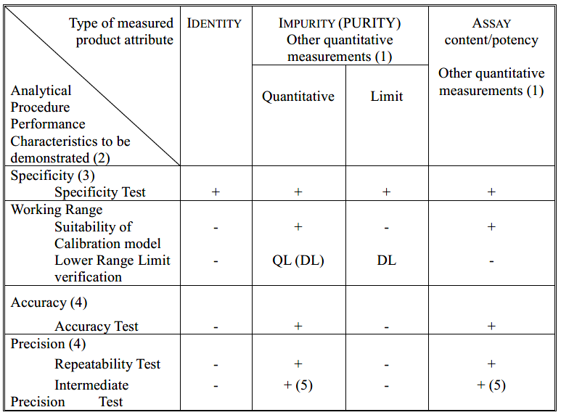  - signifies that this test is not normally evaluated  + signifies that this test is normally evaluated  ( ) signifies that this test is normally not evaluated, but in some complex cases recommended  QL, DL: Quantitation Limit, Detection Limit  (1) other quantitative measurements can follow the scheme of impurity testing, if the working range is close to the detection or quantitation limits of the technology, otherwise following the assay scheme is recommended.  (2) some performance characteristics can be substituted with technology inherent justification or qualification in the case of certain analytical procedures for physicochemical properties.  (3) a combined approach can be used alternatively to evaluating accuracy and precision separately  (4) lack of specificity of one analytical procedure could be compensated by one or more other supporting analytical procedures.  (5) Reproducibility and intermediate precision can be performed as a single set of experiments.  The objective of the analytical procedure, appropriate performance characteristics and associated criteria and appropriate validation tests (including those excluded from the validation protocol) should be documented and justified.  Prior to the validation study, a validation protocol should be generated. The protocol should contain information about the intended purpose of the analytical procedure, and performance characteristics and associated criteria to be validated. In cases where pre-existing knowledge (e.g., from development or previous validation) is used appropriate justification should be provided. The results of the validation study should be summarized in a validation report.  Figure 1 shows how knowledge can be generated during analytical procedure development as described in ICH Q14 and aid the design of a validation study.  Figure 1: Validation study design and evaluation  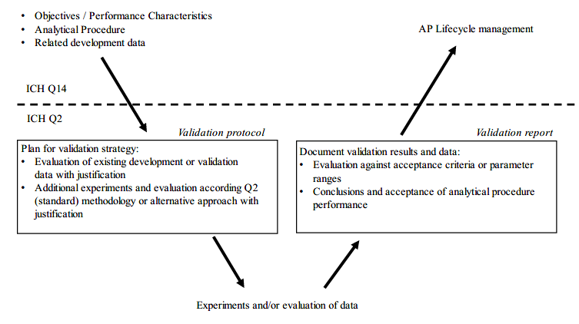
 | 3.1 Validation during the lifecycle of an analytical procedure | Changes may be required during the lifecycle of an analytical procedure. In such cases, partial or full revalidation may be required. Science and risk-based principles can be used to justify whether or not a given performance characteristic needs revalidation. The extent of revalidation depends on the analytical performance characteristics impacted by the change.  Co-validation can be used to demonstrate that the analytical procedure meets predefined performance criteria by using data from multiple sites. When transferring analytical procedures to a different laboratory, a subset of validation experiments is often performed.  Cross-validation is an approach which can be used to show that two or more analytical procedures can be used for the same intended purpose. Cross-validation should demonstrate that the same predefined performance criteria are met for these procedures.
 | 3.2 Reportable Range | The reportable range is typically derived from the product specifications and depends on the intended use of the procedure. The reportable range is confirmed by demonstrating that the analytical procedure provides results with acceptable accuracy, precision and specificity. The reportable range should be inclusive of the upper and lower specification or reporting limits, as applicable.  The table below exemplifies recommended reportable ranges for some uses of analytical procedures; other ranges may be acceptable if justified. In some cases, e.g., at low amounts, wider upper ranges may be more practical.  Table 2: Reportable ranges for common uses of analytical procedures  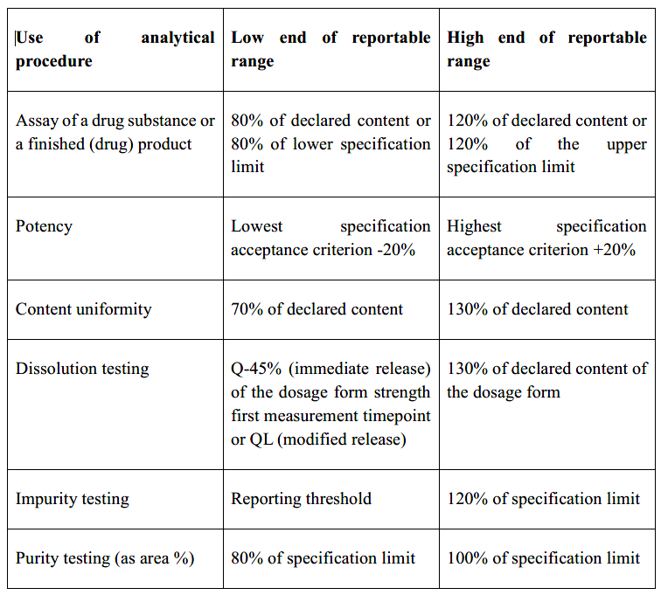
 | 3.3 Demonstration of stability indicating properties | If a procedure is a validated quantitative analytical procedure that can detect changes in relevant quality attributes of a drug substance or drug product during storage, the procedure is considered a stability-indicating test. To demonstrate specificity/selectivity of a stability-indicating test, a combination of challenges should be performed with appropriate justification from development studies. These can include: the use of samples spiked with target analytes and all known interferences; samples that have been exposed to various physical and chemical stress conditions; and actual product samples that are either aged or have been stored at higher temperature and/or humidity.
 | 3.4 Considerations for multivariate analytical procedures | For multivariate analytical procedures, results are determined through a multivariate calibration model utilizing more than one input variable (e.g., a spectrum with many wavelength variables). The multivariate calibration model relate the input data to a value for the property of interest (i.e., the model output).  Successful validation of a multivariate procedure should consider calibration, internal testing and validation.  Typically, calibration and validation are performed in two phases.  • In the first phase, model development consists of calibration and internal testing. Calibration data are used to create the calibration model. Test data are used for internal testing and optimisation of the model. The test data could be a separate set of data or part of the calibration data set used in a rotational manner. This internal test step is used to obtain an estimate of the model performance and to fine-tune an algorithm’s parameters (e.g., the number of latent variables for partial least squares (PLS)) to select the most suitable model within a given set of data and prerequisites.  • In the second phase, model validation, an independent validation data set with  independent samples is used for validation of the model.
3.4.1 Reference analytical procedure(s)

Samples used for the validation of quantitative or qualitative multivariate procedures require should have values or categories assigned to each sample, typically obtained by a validated procedure or pharmacopeial reference procedure.

When a reference analytical procedure is used, its performance should match the expected performance of the multivariate analytical procedure. Analysis by the reference procedure and multivariate data collection should be performed on the same samples (whenever possible), within a reasonable period of time to assure sample and measurement stability. In some cases, a correlation or conversion may be needed to provide the same unit of measure. Any assumptions or calculations should be described.
4 VALIDATION TESTS, METHODOLOGY AND EVALUATION |  | In the following chapters, experimental methodologies to evaluate the performance of an analytical procedure are described. The methodology described is grouped by the main performance characteristic the analytical procedure was designed for. However, it is acknowledged that information about other performance characteristics may be derived from the same dataset. Other approaches may be used to demonstrate that the analytical procedure meets the objectives and related performance criteria, if justified.
 | 4.1 Specificity / Selectivity | The specificity or selectivity of an analytical procedure can be demonstrated through absence of interference, comparison of results to an orthogonal procedure or may be inherently given by the underlying scientific principles of the analytical procedure. Some experiments can be combined with accuracy studies.  Selectivity could be demonstrated when the analytical procedure is not specific. However, the test for an analyte to be identified or quantified in the presence of potential interference should minimize that interference and prove that the test is fit for purpose.  Where one analytical procedure does not provide sufficient discrimination, a combination of two or more procedures is recommended to achieve the necessary level of selectivity.  4.1.1 Absence of interference  Specificity/selectivity can be shown by demonstrating that the identification and/or quantitation of an analyte is not impacted by the presence of other substances (e.g., impurities, degradation products, related substances, matrix, or other components present in the operating environment).  4.1.2 Orthogonal procedure comparison  Specificity/selectivity can be verified by demonstrating that the measured result of an analyte is comparable to the measured result of a second, well characterized analytical procedure (e.g., an orthogonal procedure).  4.1.3 Technology inherent justification  In some cases where the specificity of the analytical technology can be ensured and predicted by technical parameters (e.g., resolution of isotopes in mass spectrometry, chemical shifts of NMR signals), no experimental study may be required, if justified.  4.1.4 Recommended Data  4.1.4.1 Identification  For identification tests, a critical aspect is to demonstrate the capability to identify the analyte of interest based on unique aspects of its molecular structure and/or other specific properties. The capability of an analytical procedure to identify an analyte can be confirmed by obtaining positive results comparable to a known reference material with samples containing the analyte, along with negative results from samples which do not contain the analyte. In addition, the identification test can be applied to materials structurally similar to or closely related to the analyte to confirm that an undesired positive response is not obtained. The choice of such potentially interfering materials should be based on scientific judgement with a consideration of any interference that could occur.  4.1.4.2 Assay, purity- and impurity test(s)  The specificity/selectivity of an analytical procedure should be demonstrated to fulfil the accuracy requirements for the content or potency of an analyte in the sample.  Representative data (e.g., chromatograms, electropherograms or spectra) should be used to demonstrate specificity and individual components should be appropriately labelled.  Suitable discrimination should be investigated at an appropriate level (e.g., for critical separations in chromatography, specificity can be demonstrated by the resolution of the two components which elute closest to each other). Alternately, spectra of different components could be compared to assess the possibility of interference.  In case a single procedure is not considered sufficiently selective, an additional procedure should be used to ensure adequate specificity. For example, where a titration is used to assay a drug substance for release, the combination of the assay and a suitable test for impurities can be used.  The approach is similar for both assay and impurity tests:  Impurities or related substances are available:  For assay, discrimination of the analyte in the presence of impurities and/or excipients should be demonstrated. Practically, this can be performed by spiking drug substance or drug product with appropriate levels of impurities and/or excipients and demonstrating that the assay result is unaffected by the presence of these materials (e.g., by comparison with the assay result obtained on unspiked samples).  For an impurity test, discrimination can be established by spiking drug substance or drug product with appropriate levels of impurities and demonstrating the unbiased measurement of these impurities individually and/or from other components in the sample matrix.  Impurities or related substances are not available:  If impurity, related substances or degradation product materials are unavailable, specificity can be demonstrated by comparing the test results of samples containing typical impurities, related substances or degradation products with a second well-characterized procedure (e.g., pharmacopeial procedure or other validated orthogonal analytical procedure).
 | 4.2 Working Range | Depending on the sample preparation (e.g., dilutions) and the analytical procedure selected, the reportable range will lead to a specific working range. Typically, a corresponding set of sample concentrations or purity levels is presented to the analytical instrument and the respective signal responses are evaluated.  4.2.1 Response  4.2.1.1 Linear Response  A linear relationship between analyte concentration and response should be evaluated across the working range of the analytical procedure to confirm the suitability of the procedure for the intended use. The response can be demonstrated directly on the drug substance (e.g., by dilution of a standard stock solution) or separate weighings of synthetic mixtures of the drug product components, using the proposed procedure.  Initially, linearity can be evaluated with a plot of signals as a function of analyte concentration or content. Test results should be evaluated by appropriate statistical methods (e.g., by calculation of a regression line by the method of least squares).  Data derived from the regression line may help to provide mathematical estimates of the linearity. A plot of the data, the correlation coefficient or coefficient of determination, y-intercept and slope of the regression line should be provided. An analysis of the deviation of the actual data points from the regression line is helpful for evaluating linearity (e.g., for a linear response, the impact of any non-random pattern in the residuals plot from the regression analysis should be assessed).  For the establishment of linearity, a minimum of five concentrations appropriately distributed across the range is recommended; however, additional concentrations may be required for more complex models. Other approaches should be justified.  To obtain linearity, the measurements can be transformed, and a weighting factor applied to the regression analysis (i.e., in case of populations of data points with different variability (heteroscedasticity), including log or square root).  Other approaches should be justified.  4.2.1.2 Non-linear Response  Some analytical procedures may show non-linear responses. In these cases, a model or function which can describe the relationship between response of the analytical procedure and the concentration is necessary. The suitability of the model should be assessed by means of non-linear regression analysis (e.g., coefficient of determination).  For example, immunoassays or cell-based assays may show an S-shaped response. S-shaped test curves occur when the range of concentrations is wide enough that responses are constrained by upper and lower asymptotes. Common models used in this case are four-parameter or five-parameter logistical functions, though other acceptable models exist.  For these analytical procedures, the evaluation of linearity is separate from consideration of the shape of the concentration-response curve. Thus, linearity of the concentration-response relationship is not required. Instead, analytical procedure capability should be evaluated across a given working range to obtain values that are proportional to the true (known or theoretical) sample values.  4.2.1.3 Multivariate calibration  Algorithms used for construction of multivariate calibration models can be linear or non-linear, as long as the model is appropriate for establishing the relationship between the signal and the quality attribute of interest. The accuracy of a multivariate procedure is dependent on multiple factors, such as the distribution of calibration samples across the calibration range and the reference procedure error.  Linearity assessment, apart from comparison of reference and predicted results, should include information on how the analytical procedure error (residuals) changes across the calibration range. Graphical plots can be used to assess the residuals of the model prediction across the working range.  4.2.2 Validation of lower range limits  The lower range limits, detection limit (DL) and quantitation limit (QL), can be estimated using different approaches.  4.2.2.1 Based on signal-to-noise  This approach can only be applied to analytical procedures which exhibit baseline noise. Determination of the signal-to-noise ratio is performed by comparing measured signals from samples with known low concentrations of analyte with those of blank samples. Signals in an appropriate baseline region can be used instead of blank samples. The DL or QL are the minimum concentrations at which the analyte can be reliably detected or quantified, respectively. A signal-to-noise ratio of 3:1 is generally considered acceptable for estimating the detection limit. For quantitation limit, a ratio of at least 10:1 is considered acceptable.  For chromatographic procedures, the signal-to-noise ratio should be determined within a defined region and, if possible, situated equally around the place where the peak of interest would be found.  4.2.2.2 Based on the Standard Deviation of a Linear Response and a Slope  The detection limit (DL) can be expressed as:  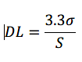  while the quantitation limit (QL) can be expressed as:  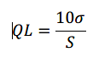  The slope S can be estimated from the regression line of the analyte. The estimate of σ can be carried out in a variety of ways, for example:  Based on the Standard Deviation of the Blank  Measurement of the magnitude of background response is performed by analysing an appropriate number of blank samples and calculating the standard deviation of the responses.  Based on the Calibration Curve  A specific calibration curve should be evaluated using samples containing an analyte in the range of the DL and QL. The residual standard deviation of a regression line (i.e., root mean square error/deviation) or the standard deviation of y-intercepts of the regression lines can be used as the standard deviation.  Based on visual evaluation  Visual evaluation can be used for both non-instrumental and instrumental procedures.  The limit is determined by the analysis of samples with known concentrations and by establishing the minimum level at which the analyte can be reliably resolved and detected or quantified.  4.2.2.3 Based on Accuracy and Precision at lower range limits  Instead of using estimated values as described in the previous approaches, the QL can be directly validated by accuracy and precision measurements.  4.2.2.4 Recommended Data  The DL and the approach used for its determination should be presented. If the DL is determined based on visual evaluation or based on signal to noise ratio, the presentation of the relevant data is considered an acceptable justification.  In cases where an estimated value for the DL is obtained by calculation or extrapolation, this estimate can subsequently be validated by the independent analysis of a suitable number of samples known to be near or prepared at the DL.  Also, the QL and the approach used for its determination should be presented.  If the QL was estimated, the limit should be subsequently validated by the analysis of a suitable number of samples known to be near or at the QL. In cases where the QL is well below (e.g., approximately 10 times lower than) the reporting limit, this confirmatory validation can be omitted with justification.  For impurity tests, the quantitation limit for the analytical procedure should be equal to or below the reporting threshold.
 | 4.3 Accuracy and Precision | Accuracy and precision can be evaluated independently, each with a predefined acceptance criterion. Combining these performance characteristics is an alternative approach for evaluation of analytical procedure suitability described in this chapter.  4.3.1 Accuracy  Accuracy should be established across the reportable range of an analytical procedure and is typically demonstrated through comparison of the measured results with an expected value. Accuracy should be demonstrated under regular test conditions of the analytical procedure (e.g., in the presence of sample matrix and using described sample preparation steps).  Accuracy is typically verified through one of the studies described below. In certain cases (e.g., small molecule drug substance assay), accuracy can be inferred once precision, response within the working range and specificity have been established.  4.3.1.1 Reference material comparison  The analytical procedure is applied to an analyte of known purity (e.g., a reference material, a well characterized impurity or a related substance) and the measured versus theoretically expected result is evaluated.  4.3.1.2 Spiking Study  The analytical procedure is applied to a matrix of all components except the analyte where a known amount of the analyte of interest has been added. In cases where all the expected components are impossible to reproduce, known quantities of the analyte can be added to the test sample. The results from measurements on unspiked and spiked samples are evaluated.  4.3.1.3 Orthogonal Procedure comparison  The results of the proposed analytical procedure are compared with those of a second well-characterized procedure that ideally applies a different measurement principle (independent procedure, see 1.2.). The accuracy of this second procedure should be reported. Orthogonal procedures can be used with quantitative impurity measurements to verify primary measurement values in cases where obtaining samples of all relevant components needed to mimic the matrix for spike recovery studies is not possible.  4.3.1.4 Recommended Data  Accuracy should be assessed using an appropriate number of determinations and concentration levels covering the reportable range (e.g., 3 concentrations/3 replicates each of the full analytical procedure).  Accuracy should be reported as the mean percent recovery by the assay of a known added  amount of analyte in the sample or as the difference between the mean and the accepted true value together with the confidence intervals.  An appropriate confidence interval (e.g., 95%) for the mean percent recovery or the difference between the mean and accepted true value (as appropriate) should be compared to the acceptance criterion to evaluate analytical procedure bias. The appropriateness of the confidence interval should be justified.  For assay, the confidence intervals found should be compatible with the corresponding assay specification.  For impurity tests, the approach for the determination of individual or total impurities should be described (e.g., weight/weight or area percent with respect to the major analyte).  For quantitative applications of multivariate analytical procedures, appropriate metrics, e.g., root mean-squared error of prediction (RMSEP), should be used. If RMSEP is found to be comparable to acceptable root mean-squared error of calibration (RMSEC) then this indicates that the model is accurate enough when tested with an independent test set. Qualitative applications such as classification, misclassification rate or positive prediction rate can be used to characterize accuracy.  4.3.2 Precision  Validation of tests for assay and for quantitative determination of impurities or purity includes an investigation of precision.  Precision should be investigated using homogeneous, authentic samples or artificially prepared samples (e.g., matrix mixtures spiked with relevant amounts of the analyte in question). If a homogeneous sample is not available, then artificially prepared samples or a sample solution can be used.  4.3.2.1 Repeatability  Repeatability should be assessed using:  a) a minimum of 9 determinations covering the reportable range for the procedure (e.g., 3 concentrations/3 replicates each);  or  b) a minimum of 6 determinations at 100% of the test concentration.  4.3.2.2 Intermediate Precision  The extent to which intermediate precision should be established depends on the circumstances under which the procedure is intended to be used. The applicant should establish the effects of random events on the precision of the analytical procedure. Typical variations to be studied include different days, environmental conditions, analysts and equipment, as relevant. Ideally, the variations tested should be based on and justified by using analytical procedure understanding from development and risk assessment (ICH Q14). Studying these effects individually is not necessary. The use of design of experiments studies is encouraged.  4.3.2.3 Reproducibility  Reproducibility is assessed by means of an inter-laboratory trial. Investigation of reproducibility is usually not required for regulatory submission but should be considered in cases of standardization of an analytical procedure, for instance, for inclusion of procedures in pharmacopoeias.  4.3.2.4 Recommended Data  The standard deviation, relative standard deviation (coefficient of variation) and confidence interval should be reported for each type of precision investigated and be compatible with the specification limits.  Additionally, for multivariate analytical procedures, the routine metrics of RMSEP encompass accuracy and precision.  4.3.3 Combined approaches for accuracy and precision  An alternative to separate evaluation of accuracy and precision is to consider their total impact by assessing against a combined performance criterion. The approach should be reflective of the individual criteria that would have been established for accuracy and precision.  Data generated during development may help determine the best approach and refine appropriate performance criteria to which combined accuracy and precision are compared.  Combined accuracy and precision can be evaluated by use of a prediction interval (to assess the probability that the next reportable value falls within the acceptable range) or a tolerance interval (to assess the proportion of all future reportable values that will fall within the acceptable range). Other approaches may be acceptable if justified.  4.3.3.1 Recommended Data  If a combined performance criterion is chosen, results should be reported as combined value to provide appropriate overall knowledge of the suitability of the analytical procedure. If relevant, the individual results for accuracy and precision should be provided as supplemental information. The approach used should be described.
 | 4.4 Robustness | The evaluation of the analytical procedure’s suitability within the intended operational environment should be considered during the development phase and depends on the type of procedure under study. Robustness testing should show the reliability of an analytical procedure with respect to deliberate variations in parameters. The robustness evaluation can be submitted as part of development data for an analytical procedure on a case-by-case basis or should be made available upon request.  For further details, see ICH Q14.
5. GLOSSARY |  | ACCURACY  The accuracy of an analytical procedure expresses the closeness of agreement between the value which is accepted either as a conventional true value or as an accepted reference value and the value measured. (ICH Q2)  ANALYTICAL PROCEDURE  The analytical procedure refers to the way of performing the analysis. The analytical procedure description should include in detail the steps necessary to perform each analytical test. (ICH Q2)  ANALYTICAL PROCEDURE ATTRIBUTE  A technology specific property that should be within an appropriate limit, range or distribution to ensure the desired quality of the measured result. For example, attributes for chromatography measurements may include peak symmetry factor and resolution. (ICH Q14)  ANALYTICAL PROCEDURE CONTROL STRATEGY  A planned set of controls derived from current analytical procedure understanding that ensures the analytical procedure performance and the quality of the measured result. (ICH Q14)  ANALYTICAL PROCEDURE PARAMETER  Any factor (including reagent quality) or analytical procedure operational step that can be varied continuously (e.g., flow rate) or specified at controllable, unique levels. (ICH Q14)  ANALYTICAL PROCEDURE VALIDATION STRATEGY  An analytical procedure validation strategy describes how to select the analytical procedure performance characteristics for validation. In the strategy, data gathered during development studies (e.g., using MODR or PAR) and system suitability tests (SSTs) can be applied to validation and an experimental scheme for future movements of parameters within an MODR/PAR can be predefined. (ICH Q14)  ANALYTICAL TARGET PROFILE (ATP)  A prospective summary of the performance characteristics describing the intended purpose and the anticipated performance criteria of an analytical measurement. (ICH Q14)  CALIBRATION MODEL  A model based on analytical measurements of known samples that relates the input data to a value for the property of interest (i.e., the model output). (ICH Q2)  CONTROL STRATEGY  A planned set of controls, derived from current product and process understanding, that assures process performance and product quality. The controls can include parameters and attributes related to drug substance and drug product materials and components, facility and equipment operating conditions, in-process controls, finished product specifications, and the associated methods and frequency of monitoring and control. (ICH Q10)  CO-VALIDATION  Demonstration that the analytical procedure meets its predefined performance criteria when used at different laboratories for the same intended purpose. Co-validation can involve all (full revalidation) or a subset (partial revalidation) of performance characteristics potentially impacted by the change in laboratories. (ICH Q2)  CRITICAL QUALITY ATTRIBUTE (CQA)  A physical, chemical, biological or microbiological property or characteristic that should be within an appropriate limit, range, or distribution to ensure the desired product quality. (ICH Q8)  CROSS-VALIDATION  Demonstration that two or more analytical procedures meet the same predefined performance criteria and can therefore be used for the same intended purpose. (ICH Q2)  DETECTION LIMIT  The detection limit is the lowest amount of an analyte in a sample which can be detected but not necessarily quantitated as an exact value. (ICH Q2)  DETERMINATION  The reported value(s) from single or replicate measurements of a single sample preparation as per the validation protocol. (ICH Q2)  ESTABLISHED CONDITIONS (ECs)  ECs are legally binding information considered necessary to assure product quality. As a consequence, any change to ECs necessitates a submission to the regulatory authority. (ICH Q12)  INTERMEDIATE PRECISION  Intermediate precision expresses within-laboratories variations. Factors to be considered should include potential sources of variability, for example, different days, different environmental conditions, different analysts and different equipment. (ICH Q2)  KNOWLEDGE MANAGEMENT  A systematic approach to acquiring, analysing, storing and disseminating information related to products, manufacturing processes and components. (ICH Q10)  METHOD OPERABLE DESIGN REGION (MODR)  A combination of analytical procedure parameter ranges within which the analytical procedure performance criteria are fulfilled and the quality of the measured result is assured. (ICH Q14)  ONGOING MONITORING  The collection and evaluation of analytical procedure performance data to ensure the quality of measured results throughout the analytical procedure lifecycle. (ICH Q14)  PERFORMANCE CHARACTERISTIC  A technology independent description of a characteristic to ensure the quality of the measured result. Typically, accuracy, precision, specificity/selectivity and range may be considered. The term was previously called VALIDATION CHARACTERISTIC. (ICH Q2)  PERFORMANCE CRITERION  An acceptance criterion describing a numerical range, limit or desired state to ensure the quality of the measured result. (ICH Q14)  PLATFORM ANALYTICAL PROCEDURE  A platform analytical procedure can be defined as a multi-product method suitable to test quality attributes of different products without significant change to its operational conditions, system suitability and reporting structure. This type of method would apply to molecules that are sufficiently alike with respect to the attributes that the platform method is intended to measure. (ICH Q2)  PRECISION  The precision of an analytical procedure expresses the closeness of agreement (degree of scatter) between a series of measurements obtained from multiple samplings of the same homogeneous sample under the prescribed conditions. Precision can be considered at three levels: repeatability, intermediate precision and reproducibility.  The precision of an analytical procedure is usually expressed as the variance, standard  deviation or coefficient of variation of a series of measurements. (ICH Q2)  PROVEN ACCEPTABLE RANGE FOR ANALYTICAL PROCEDURES (PAR)  A characterised range of an analytical procedure parameter for which operation within this range, while keeping other parameters constant, will result in an analytical measurement meeting relevant performance criteria. (ICH Q14)  QUALITY RISK MANAGEMENT  A systematic process for the assessment, control, communication and review of risks to the quality of the drug (medicinal) product across the product lifecycle. (ICH Q9)  QUANTITATION LIMIT  The quantitation limit is the lowest amount of analyte in a sample which can be quantitatively determined with suitable precision and accuracy. The quantitation limit for an analytical procedure should not be more than the reporting threshold. The quantitation limit is a parameter used for quantitative assays for low levels of compounds in sample matrices, and, particularly, is used for the determination of impurities and/or degradation products. (ICH Q2)  RANGE  The range of an analytical procedure is the interval between the lowest and the highest reportable results in which the analytical procedure has a suitable level of precision, accuracy and response. (ICH Q2)  REPORTABLE RANGE  The reportable range of an analytical procedure includes all values from the lowest to the highest reportable result for which there is a suitable level of precision and accuracy. Typically, the reportable range is given in the same unit as the specification. (ICH Q2)  WORKING RANGE  The working range of an analytical procedure is the lowest and the highest concentration that the analytical procedure provides meaningful results. Working ranges may be different before sample preparation (sample working range) and when presented to the analytical instrument (instrument working range). (ICH Q2)  REAL TIME RELEASE TESTING (RTRT)  The ability to evaluate and ensure the quality of the in-process and/or final product based on process data, which typically include a valid combination of measured material attributes and process controls. (ICH Q8)  REPEATABILITY  Repeatability expresses the precision under the same operating conditions over a short interval of time. Repeatability is also termed intra-assay precision. (ICH Q2)  REPORTABLE RESULT  The result as generated by the analytical procedure after calculation or processing and applying the described sample replication. (ICH Q2)  REPRODUCIBILITY  Reproducibility expresses the precision between laboratories (e.g., inter-laboratory studies, usually applied to standardization of methodology). (ICH Q2)  RESPONSE  The response of an analytical procedure is its ability (within a given range) to obtain a signal which is effectively related to the concentration (amount) of analyte in the sample by some known mathematical function. (ICH Q2)  REVALIDATION  Demonstration that an analytical procedure is still fit for its intended purpose after a change to the product, process or the analytical procedure itself. Revalidation can involve all (full revalidation) or a subset (partial revalidation) of performance characteristics. (ICH Q2)  ROBUSTNESS  The robustness of an analytical procedure is a measure of its capacity to meet the expected performance requirements during normal use. Robustness is tested by deliberate variations of analytical procedure parameters. (ICH Q14)  SAMPLE SUITABILITY ASSESSMENT  A sample or sample preparation is considered suitable if the measurement response on the sample satisfies pre-defined acceptance criteria for the analytical procedure attributes that have been developed for the validated analytical procedure. Sample suitability is a pre-requisite for the validity of the result along with a satisfactory outcome of the system suitability test. Sample suitability generally consists of the assessment of the similarity of the response between a standard and the test sample and may include a requirement of no interfering signals arising from the sample matrix. (ICH Q14)  SPECIFICITY/SELECTIVTY  Specificity and selectivity are both terms to describe the extent to which other substances interfere with the determination of a substance according to a given analytical procedure. Such other substances might include impurities, degradation products, related substances, matrix or other components present in the operating environment. Specificity is typically used to describe the ultimate state, measuring unequivocally a desired analyte. Selectivity is a relative term to describe to which extent particular analytes in mixtures or matrices can be measured without interferences from other components of similar behaviour. (ICH Q2)  SYSTEM SUITABILITY TEST (SST)  These tests are developed and used to verify that the measurement system and the analytical operations associated with the analytical procedure are adequate for the intended analysis and increase the detectability of potential failures (ICH Q14)  TOTAL ANALYTICAL ERROR  Total analytical error (TAE) represents the overall error in a test result that is attributed to imprecision and inaccuracy. TAE is the combination of both, systematic error of the procedure and random measurement error. (ICH Q14)  VALIDATION STUDY  An evaluation of prior knowledge, data or deliberate experiments to determine the suitability of an analytical procedure for its intended purpose. (ICH Q2)  VALIDATION TEST  Validation tests are deliberate experiments designed to authenticate the suitability of an analytical procedure for its intended purpose. (ICH Q2)  MULTIVARIATE GLOSSARY  CALIBRATION DATA SET  A set of data with matched known characteristics and measured analytical results, that spans the desired operational range. (ICH Q2)  DATA TRANSFORMATION  Mathematical operation on model input data to assume better correlation with the output data and simplify the model structure. (ICH Q14)  INDEPENDENT SAMPLE  Independent samples are samples not included in the calibration set of a multivariate model. Independent samples can come from the same batch from which calibration samples are selected. (ICH Q2)  INTERNAL TESTING  Internal testing is a process of checking if unique samples processed by the model yield the correct predictions (qualitative or quantitative).  Internal testing serves as means to establish the optimal number of latent variables, estimate the standard error and detect potential outliers. Internal testing is preferably done by using samples not included in the calibration set. Alternatively, internal testing can be done using a subset of calibration samples, while temporarily excluding them from the model calculation.(ICH Q2)  INTERNAL TEST SET  A set of data obtained from samples that have physical and chemical characteristics that span a range of variabilities similar to the samples used to construct the calibration set. (ICH Q14)  LATENT VARIABLES  Mathematically derived variables that are directly related to measured variables and are used in further processing. (ICH Q2)  MODEL VALIDATION  The process of determining the suitability of a model by challenging it with independent test data and comparing the results against prespecified criteria. For quantitative models, validation involves confirming the calibration model’s performance with an independent dataset. For identification libraries, validation involves analysing samples (a.k.a., challenge samples) not represented in the library to demonstrate the discriminative ability of the library model. (ICH Q2)  MODEL MAINTENANCE  Safeguards over the lifecycle of a multivariate model to ensure continued model performance, often including outlier diagnostics and resulting actions for model redevelopment or change in the maintenance plans. (ICH Q14)  MULTIVARIATE ANALYTICAL PROCEDURE  An analytical procedure where a result is determined through a multivariate calibration model utilizing more than one input variable. (ICH Q2)  OUTLIER DIAGNOSTIC  Tests that can identify unusual or atypical data in a multivariate analytical procedure. (ICH Q14)  REFERENCE PROCEDURE  A separate analytical procedure used to obtain the reference values of the calibration and validation samples for a multivariate analytical procedure. (ICH Q2)  REFERENCE SAMPLE  A sample representative of the test sample with a known value for the property of interest, used for calibration. (ICH Q14)  VALIDATION SET  A set of data used to give an independent assessment of the performance of the calibration model, ideally over a similar operating range. (ICH Q14)
6 References |  | ICH Q14 Analytical Procedure Development
7 ANNEX 1 SELECTION OF VALIDATION TESTS |  | Figure 2: Selection of validation tests based on the objective of the analytical procedure  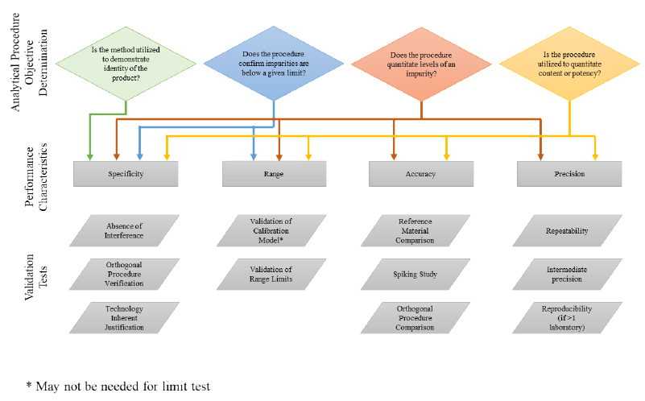
8 ANNEX 2 ILLUSTRATIVE EXAMPLES FOR ANALYTICAL TECHNIQUES |  | Table 3: Examples for Quantitative separation techniques  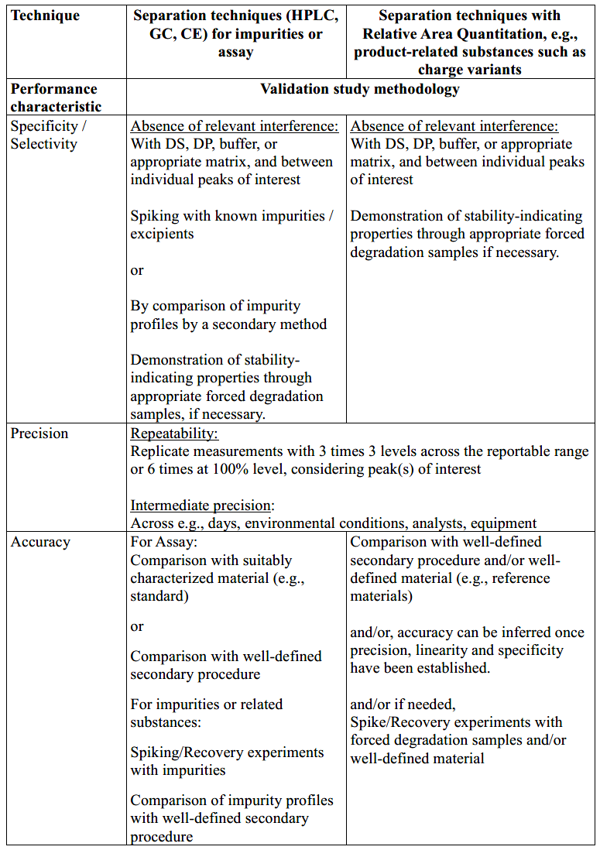  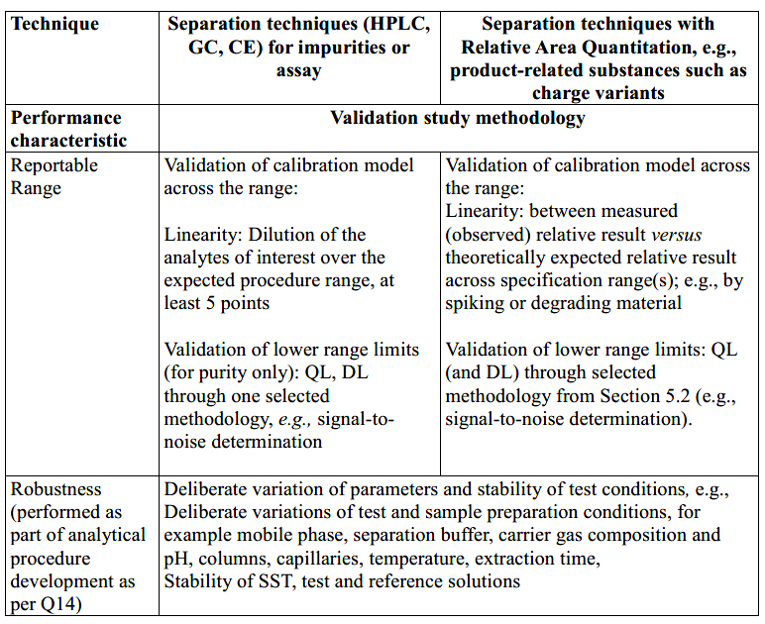  Table 4: Example for Elemental Impurities by ICP-OES or ICP-MS as purity test  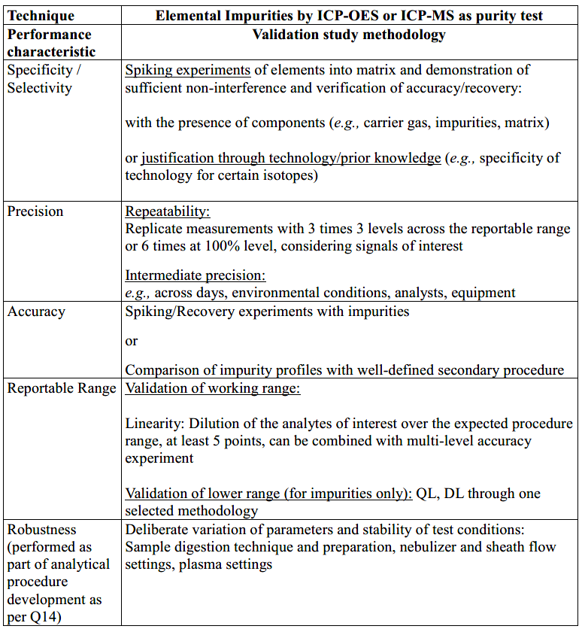  Table 5: Example for Dissolution with HPLC as product performance test for an immediate release dosage form  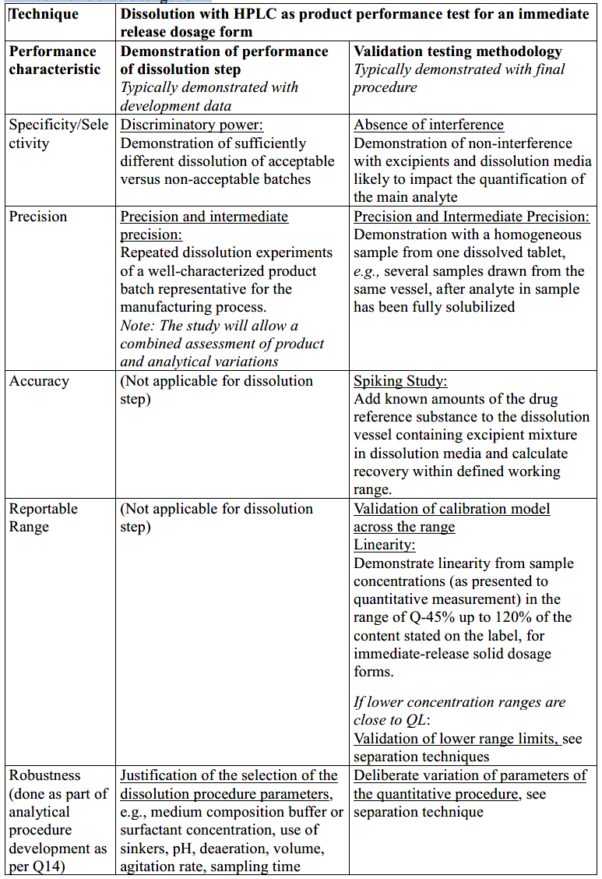  Table 6: Example for Quantitative 1 H-NMR for the Assay of an API  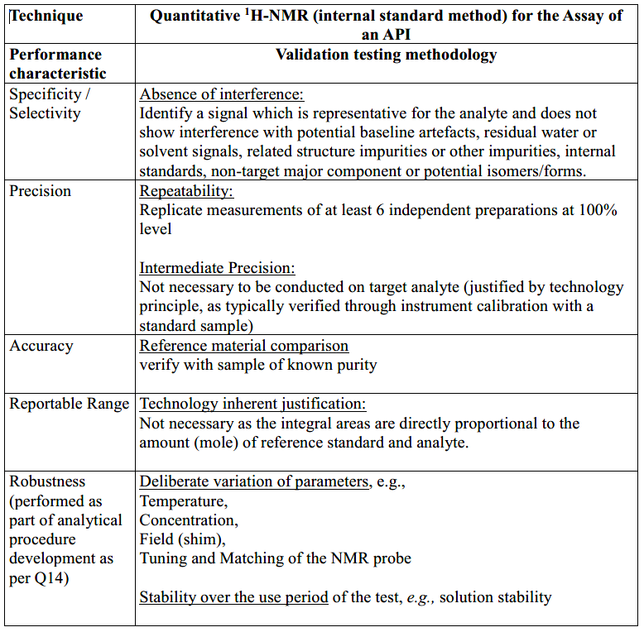  Table 7: Example for Biological Assays  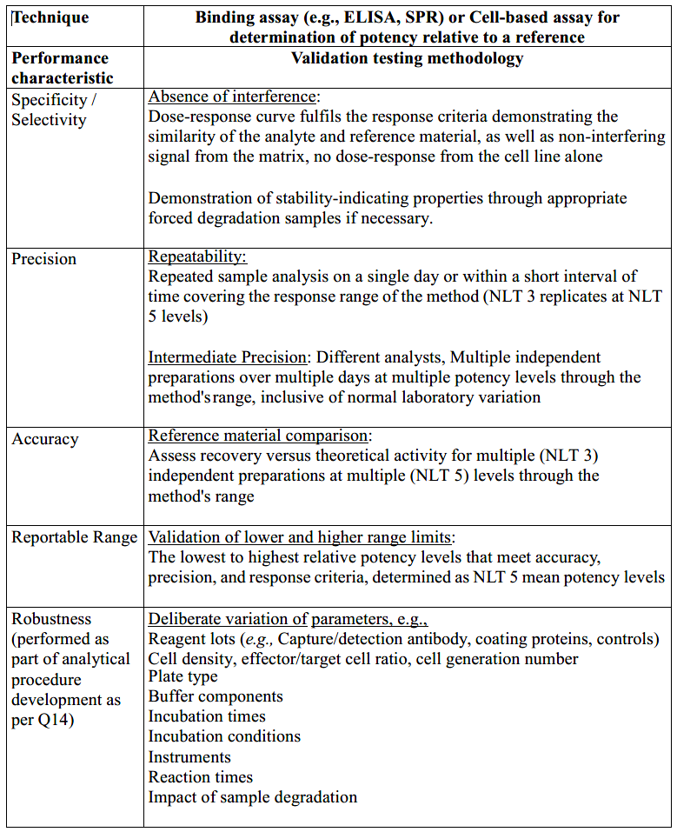  Table 8: Example for quantitative PCR  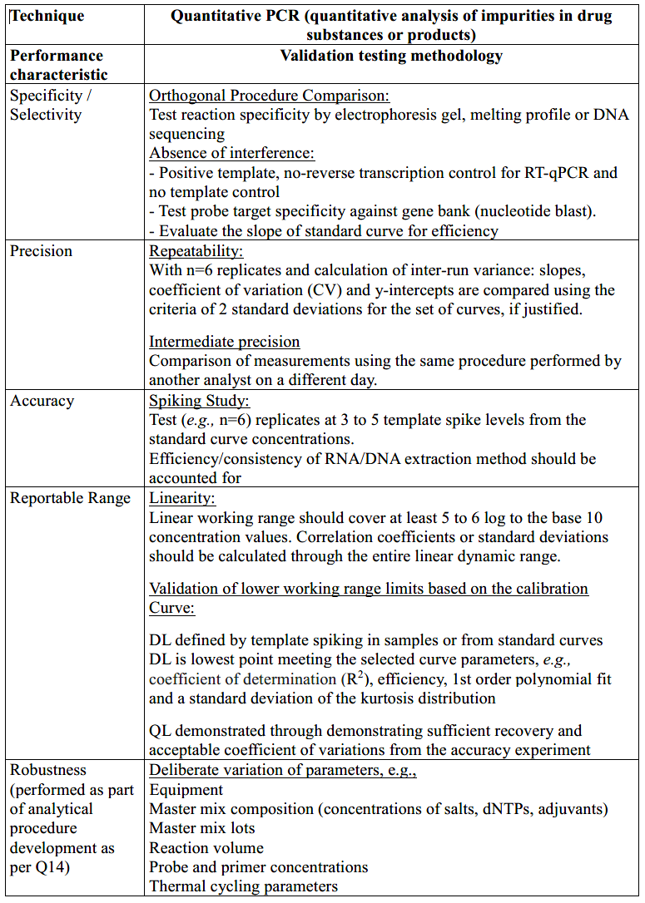  Table 9: Example for particle size measurement  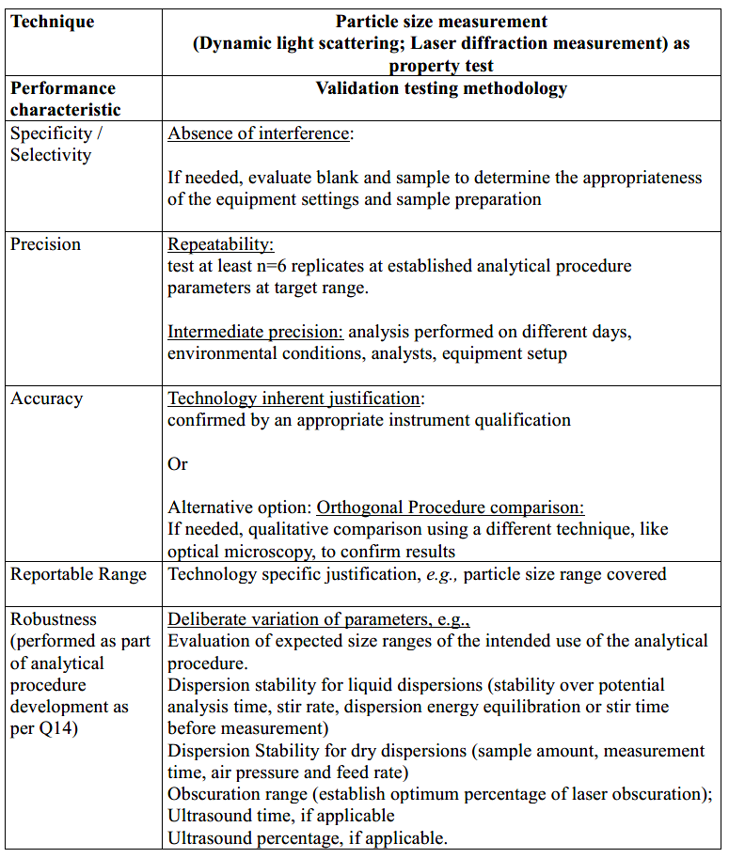  Table 10: NIR  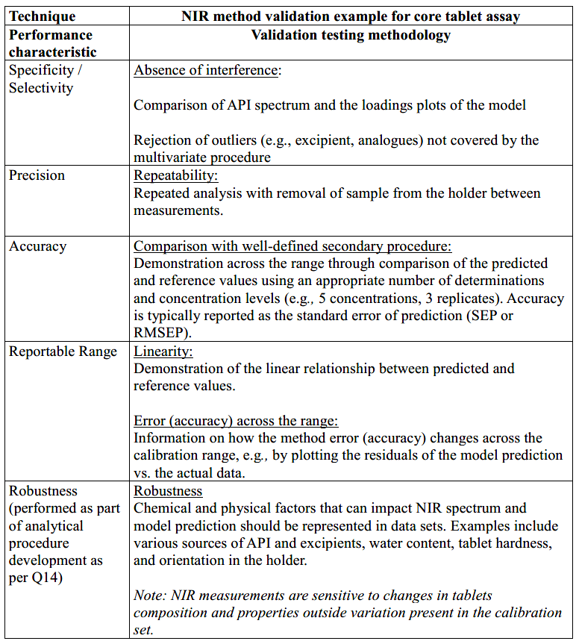  Table 11: Example for Quantitative LC/MS  