ICH HARMONISED GUIDELINE
Addendum to ICH M7(R2): Application of the Principles of the ICH M7 Guideline to Calculation of
Compound-Specific Acceptable Intakes

(Draft version, Endorsed on October 6, 2021)
指引意見彙整表
段落 | 標題 | 內文 (摘自M7(R2) draft guideline，仍以ICH文件為準) | 相關建議及意見  (請提供中英文內容)
1. List of changes to the M7 Guideline and Addendum in line with the ICH process for the 2 maintenance of the M7 Guideline: |  | - The M7 document was physically separated into a main Guideline and a separate Addendum including the monographs;  - In the main M7 Guideline, the HIV duration was changed from “>1-10 years to >10 years” to “lifetime“;  - In the main M7 Guideline, the monograph table was edited to include the 7 new monographs and 1 note;  - In the Addendum, 7 new monographs and 1 note were added (see pages 4-51 of this document):  a. Acetaldehyde, Dibromoethane, Epichlorohydrin, Ethyl Bromide, Formaldehyde, Styrene, Vinyl Acetate;  b. Note 2;  - In the main M7 Guideline and Addendum, standard grammatical and formatting edits were made;  - In the main M7 Guideline and Addendum, additional corrections in content were made that were determined to be minor by the M7(R2) Maintenance Expert Working Group.
Acceptable Intakes (AIs) or Permissible Daily Exposures (PDEs) |  | 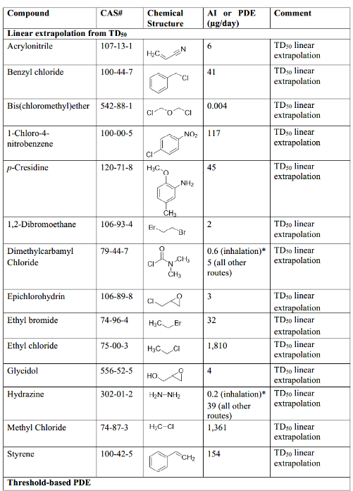  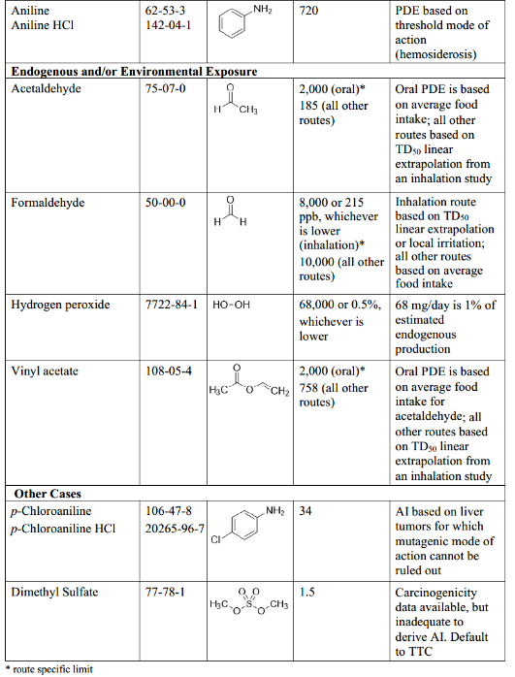
Acetaldehyde (CAS# 75-07-0)
 | Potential for human exposure | Acetaldehyde is formed endogenously in the human body from the metabolism of ethanol and carbohydrates as well as from bacteria in the alimentary tract. Humans are exposed to acetaldehyde mainly in food, alcoholic beverages, cigarette smoke and to a lesser extent from environmental emissions (Ref. 1, 2). The determination of endogenous acetaldehyde in blood, breath and saliva is challenging as the techniques are prone to artifacts and contaminants (Ref. 3, 4). Nevertheless, a daily endogenous production of 360 mg/day of acetaldehyde was calculated based on a constant endogenous total acetaldehyde concentration in the blood of 2.2 ±1.1 μmol/L (Ref. 3) and acetaldehyde clearance of 0.95 L/min (Ref. 5). Average acetaldehyde consumption of up to 48 mg/day comes from consumption of alcoholic beverages (Ref. 6). Endogenous acetaldehyde concentrations and the associated cancer risk are significantly higher in individuals with an ALDH II genetic polymorphism (Ref. 7). The exogenous exposure from food (without alcoholic beverages or added acetaldehyde as flavoring agent) was estimated to be around 2 mg/day on average and 8 mg/day for the upper 95% of the German population (Ref. 8), JECFA estimated food additive consumption to be 9.7 mg/day in the USA and 11 mg/day in Europe although this estimate is restricted to consumers who eat foods in which acetaldehyde is added as a flavor (Ref. 9) and the Japanese Food Safety Committee estimated domestic consumption between 9.6 – 19.2 mg/day (Ref. 10). Acetaldehyde is used in synthesis of pharmaceuticals.
 | Mutagenicity/genotoxicity | The genotoxicity of acetaldehyde has been previously reviewed by the Chemical Evaluation and Research Institute and others (Ref. 1, 5, 11-18). Acetaldehyde was negative in comprehensive bacterial Ames reverse mutation assays, but induced increases in mutations at the hypoxanthine-guanine-phosphoribosyl transferase (hprt) locus in mammalian cells, which included point mutations demonstrated by sequencing (Ref. 13). DNA- and DNA-protein adducts were observed in cultured cells treated with acetaldehyde and DNA adducts were measured in urine of healthy volunteers and in blood cells from persons who abuse alcohol. Acetaldehyde is primarily an inducer of larger scale chromosomal effects. It induces chromosomal aberrations and micronuclei in vitro and was positive in the mouse lymphoma L5178Y tk+/- assay. Acetaldehyde induced increases in micronuclei in the bone marrow of rats and mice.
 | Carcinogenicity | Acetaldehyde is an IARC 2B carcinogen and “acetaldehyde associated with the consumption of alcoholic beverages” is an IARC 1 carcinogen, i.e. “carcinogenic to humans.” Acetaldehyde was carcinogenic in rats and hamsters after inhalation exposure (Ref. 1).  In humans, acetaldehyde is the primary metabolite of alcohol and high as well as low alcohol consumption has been correlated with an increased relative risk for certain human cancers (e.g. oral cavity, pharynx cancer and breast cancer) (Ref. 19, 20). The relative risk was increased in smokers showing a tobacco-alcohol synergism and a possible contribution of acetaldehyde derived from cigarette smoke (Ref. 19). Also, geographical regions with consumption of alcoholic beverages containing high acetaldehyde concentrations showed a tendency for higher incidence of squamous-cell cancer and cancer of the esophagus (Ref. 21). Furthermore, available epidemiological data indicate that there is an increased risk for development of alcohol-related cancers for those individuals who are deficient in detoxifying acetaldehyde to acetate by ALDH. Especially the genetic variant ALDH2*1/*2 is strongly associated with alcohol-related cancers in not only heavy drinkers but those with moderate levels of alcohol consumption (Ref. 1, 5, 19). Meta analyses and large cohort studies report conflicting conclusions about whether there are increased risks of head, neck and mammary tumors associated with moderate alcohol consumption in the U.S. populations where ALDH deficiency is relatively infrequent (Ref. 22, 23). The literature on the elevated risk of head and neck cancers associated with acetaldehyde exposure in heavy drinkers, smokers, and in moderate drinkers with ALDH deficiency does not include discussion of whether those exposures are also associated with histopathological changes consistent with irritation or tissue proliferation.  In rodents, only inhalation carcinogenicity studies are available in the Carcinogenic Potency Database (CPDB) (Ref. 24). The most robust study was conducted with Wistar rats (Ref. 25) with whole-body inhalation exposure to 0, 750, 1500 or 3000/1000 ppm (reduced after 11 months due to toxicity), 6 h/day at 5 days/week for up to 28 months. The doses shown in the CPDB were 0, 70.8, 142 and 147 mg/kg for male rats and 0, 101, 202 and 209 mg/kg for female rats. In the high- dose group, 50% of the male and 42% of the female animals had died by week 67 and no high-dose animals were alive by week 102. An increased incidence of tumors at the site of contact, i.e. nasal squamous cell carcinomas, was observed in males (1/49, 1/52, 10/53 and 15/49 corresponding to control, low, mid and high dose groups) and females (0/50, 0/48, 5/53 and 17/53, respectively) at the end of the study. There were also increases in nasal adenocarcinomas at all doses, the incidences were 0/49, 16/52, 31/53 and 21/49 in males and 0/50, 6/48, 26/53 and 21/53 in females, respectively. Based on these data, the TD50 value shown in the CPDB was estimated to be 185 mg/kg for nasal adenocarcinoma in male rats in the most sensitive sex and tissue.  An oral carcinogenicity study (Ref. 26) was conducted in Sprague Dawley rats with acetaldehyde administration in drinking water. In this study, 50 rats per group were given 0, 50, 250, 500, 1500 and 2500 mg/L acetaldehyde in drinking water for 104 weeks and the experiment was terminated 97 when the last animal died at 161 weeks of age. The concentrations correspond to 0, 5, 25, 49, 147 and 246 mg/kg/day for male rats and 0, 5, 27, 53, 155 and 260 mg/kg/day for female rats, respectively. Incidences of adenocarcinomas, lymphomas and leukemias, mammary tumors, and cranial osteosarcomas, were described by the investigators as significantly greater in at least one group of exposed rats, relative to control. There was no increase in malignant tumors at the site of contact organs, i.e. the oral cavity and gastrointestinal tract, or in the liver.  This study suggests that acetaldehyde may be carcinogenic after intake via drinking water. However, there was no clear dose-response relationship and therefore, many evaluators found that no clear conclusion can be drawn from this study (Ref. 5, 12, 19). In another evaluation of the same data, two different dose-response models were used to estimate cancer potency and the authors concluded that their quantitative risk assessment indicates the need to lower acetaldehyde exposure in the general population but also acknowledged that naturally occurring acetaldehyde cannot be reduced (Ref. 21). In this model, the carcinogenic potency was calculated for all tumor bearing animals because the authors found that there was insufficient statistical power to generate a model for any specific cancer site. A TD50 related to oral administration of acetaldehyde was not calculated.
 | Acetaldehyde – Details of carcinogenicity studies | 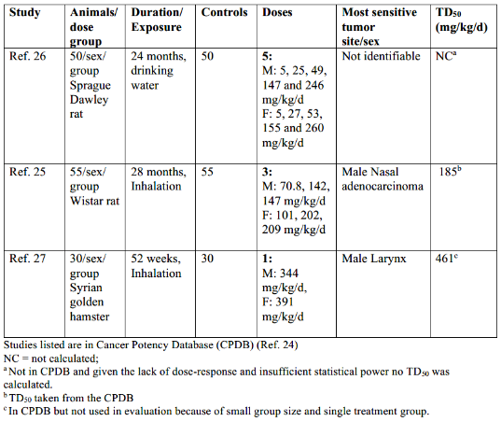
 | Mode of action for carcinogenicity | Acetaldehyde is a strong electrophile and is capable of reacting with strong nucleophiles, for example DNA bases or amino acid residues on proteins. Although not mutagenic in the standard bacterial reversion assay, evidence for DNA-reactivity and mutagenicity was shown for acetaldehyde by the presence of DNA and DNA-protein adducts in vitro and in vivo, as well as the positive result in the in vitro hprt mutagenicity assay in mammalian cells. Despite its reactive nature, there is evidence for a non-linear dose response associated with the genotoxicity and carcinogenicity of acetaldehyde (Ref. 14). The dose-response of acetaldehyde-induced adducts at concentrations between 1 and 1000 uM has been measured in a cell culture system allowing the discrimination between endogenous and exogenous adducts induced by added acetaldehyde. These concentrations are comparable to salivary acetaldehyde concentrations measured before and after consumption of beverages containing alcohol with or without acetaldehyde (Ref. 28, 29). The exogenous adducts only exceeded the endogenous background level of adducts above a critical concentration.  Aldehyde hydrogenase (ALDH), which efficiently detoxifies acetaldehyde, is responsible for the non-linear dose response relationship. ALDH enzymes are expressed in the mitochondria and cytosol of most tissues (e.g., liver, gastrointestinal tract, kidneys, nasal epithelium/olfactory epithelium, lung) and they metabolize acetaldehyde to form acetate and one proton (Ref. 30). The release of protons can reduce cellular pH and thus cause non-specific cytotoxicity with subsequent proliferative effects. The importance of detoxification is shown in ALDH deficient animal models. For example, acetaldehyde induced chromosome damage and mutation is observed in mice deficient in ALDH2 activity following inhalation and oral (gavage) exposure, but not in ALDH2-proficient mice (Ref. 31). Similarly, more acetaldehyde derived DNA adducts were seen in alcoholics with a deficient aldehyde dehydrogenase genotype (allelic variant type ALDH2*1/2*2 with about 10% residual ALDH activity) compared to those with efficient genotype ALDH2*1/2*1 (Ref. 32) and moderate drinkers with the genotype are at increased risk of head and neck cancers (IARC).  The inhalation carcinogenicity data and mechanistic study data suggest that acetaldehyde cancer risk is highest at and possibly limited to the site-of-contact. The nasal tumors in inhalation carcinogenicity studies were only found at inhalation doses also associated with cytotoxicity and severe irritation causing regenerative proliferation consistent with the hypothesis that there could be promotion of growth of mutated cells (Ref. 5, 14). Detoxification of acetaldehyde by ALDH, in airway cells may make tumor induction less likely at lower, non-irritating doses. However, there are no published measurements which would allow discrimination between the irritating effect and the potential mutagenic effect in cancer development.
 | Regulatory and/or published limits | Acetaldehyde is listed in the US Food and Drug Administration’s (FDA’s) ‘generally recognized as safe’ (GRAS) list for flavoring substances and adjuvants – 21 CFR 182.60. The Japanese FSC confirmed the absence of safety concerns when used as a flavoring agent as it is completely metabolized into non-reactive acetic acid and finally CO2, and thus, its level as a flavoring agent is presumed not to exceed the physiological range (Ref. 10). The Joint FAO/WHO Expert Committee on Food Additives (JECFA) evaluation has concluded that there are no safety concerns at current levels of intake when used as a flavoring agent, which was 11 mg/day in Europe and 168 9.7 mg/day in the United States (Ref. 9).  The Committee on Emergency and Continuous Exposure Guidance Levels for Selected Submarine Contaminants (Ref. 33) recommended a Continuous Exposure Guidance Level (CEGL) of 2 ppm corresponding to 3.6 mg/m³. This represents an exposure of 3.6 mg/m³ x 28.8 m³ (24 hours in a day – ICH Q3C assumption) = 104 mg/day.  The US EPA did not consider a threshold for acetaldehyde carcinogenicity and has calculated that a concentration of 5 μg/m³ acetaldehyde represents a 10⁻⁵ excess lifetime cancer risk based on the rat inhalation carcinogenicity study and application of linear extrapolation (Ref. 34). For a 24 h exposure, this represents 5 μg/m³x 28.8 m³ = 144 μg/day. EPA did not consider the risk via the oral route.
 | Permissible Daily Exposure (PDE) for oral exposure | Rationale for selection of study for PDE calculation  Given the weight of evidence for a non-linear dose-response for the carcinogenicity of acetaldehyde following oral administration and high background exposure from a wide variety of foods, a permissible daily exposure (PDE) of 2 mg/day is identified for oral limit based on the estimated average intake of acetaldehyde from food around 2 mg/day (Ref. 8).  PDE (oral) = 2 mg/day
 | Acceptable intake (AI) for all other routes | Rationale for selection of study for AI calculation  The inhalation study in rats by Woutersen et al. (Ref. 25) was used to derive the AI for all other routes. This study comprises group sizes of 50/sex/dose and animals were treated for life time (i.e., 24 months). According to M7’s recommendations for selecting the most relevant study for deriving an AI, this is considered the most appropriate and robust study available for acetaldehyde. The inhalation carcinogenicity data and mechanistic study data suggest acetaldehyde cancer risk to be associated with cytotoxicity at the site of contact as nasal tumors were only found at doses also associated with cytotoxicity and severe irritation causing regenerative proliferation a promotion of growth of mutated cells.
 | Calculation of AI | Lifetime AI = TD50/50000 x 50 kg  Lifetime AI =185 mg/kg/day/50000 x 50 kg  Lifetime AI (all other routes) = 185 µg/day
 | References | 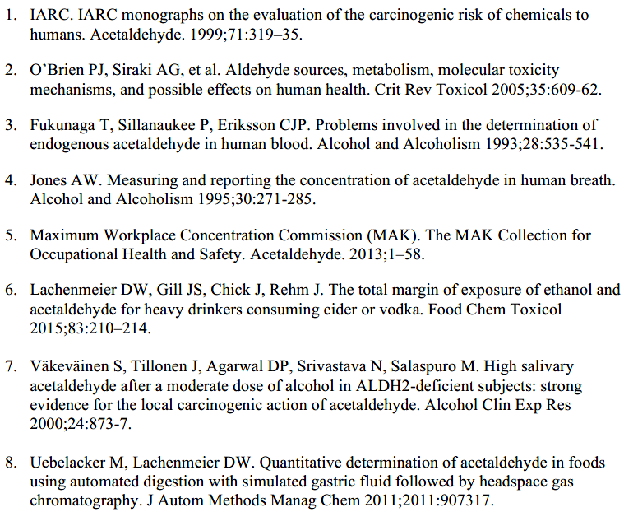  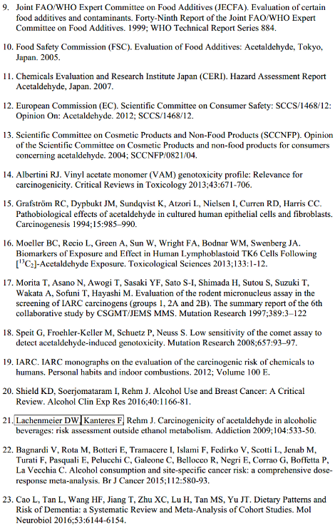  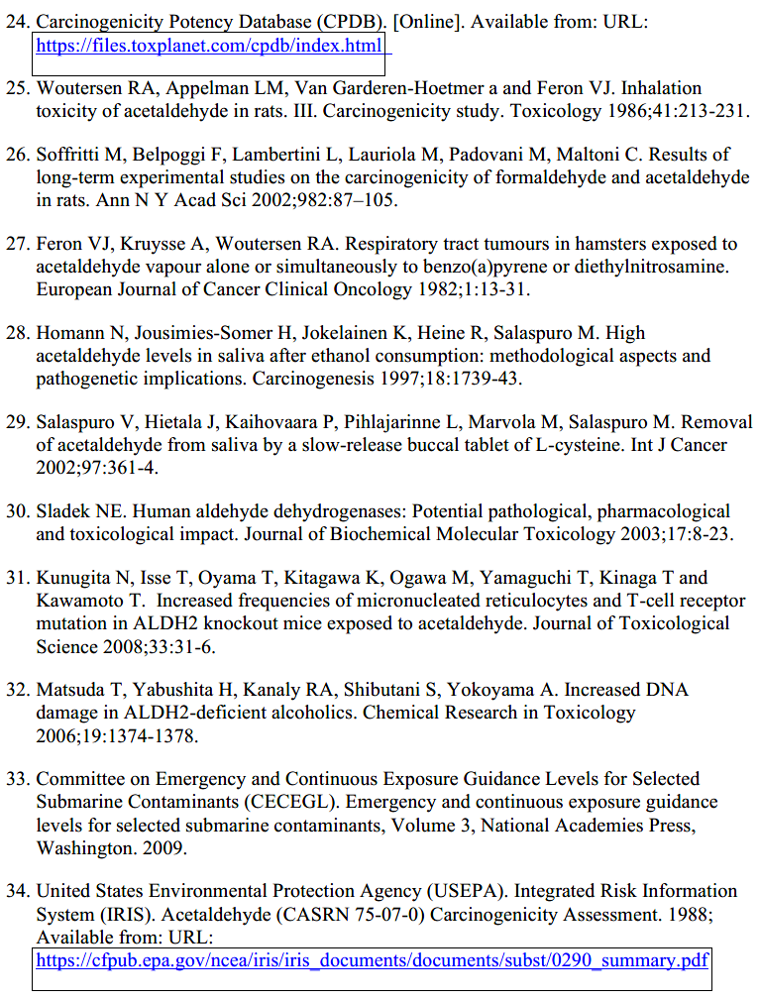
1,2-Dibromoethane (CAS# 106-93-4)
 | Potential for human exposure | 1,2-Dibromoethane was previously used as an insect fumigant and soil nematocide but was banned by the U.S. EPA and the EC due to toxicity concerns (Ref. 1, 2). 1,2-Dibromoethane is used in the synthesis of active pharmaceutical ingredients.
 | Mutagenicity/genotoxicity | 1,2-Dibromoethane is mutagenic/genotoxic in vitro and in vivo. The mutagenicity of 1,2-dibromoethane was evaluated in Salmonella tester strains TA 1535, TA 1537, TA 98, TA 100, TA 1538 and in E. coli WP2, both in the presence and absence of added metabolic activation by Aroclor-induced rat liver S9 fraction (Ref. 3-7). 1,2-Dibromoethane was mutagenic in Salmonella 318 typhimurium strains TA 100, TA 1535, TA 98 and E. coli WP2, with and without metabolic activation. 1,2-Dibromoethane was positive in the mouse lymphoma assay, with and without metabolic activation (Ref. 8). It caused a dose-dependent increase in DNA repair in both spermatocytes and hepatocytes in vitro (Ref. 9) and induced mutations in Chinese hamster ovary (CHO) cells (Ref. 10). 1,2-Dibromoethane increased the frequencies of chromosome aberrations in a dose-dependent manner in CHO cells (Ref. 11). In vivo in the Comet assay in rats, positive results were obtained in liver and glandular stomach following treatment with 1,2-dibromoethane at 100 mg/kg. 1,2-Dibromoethane was negative in the bone marrow and erythrocyte micronucleus test in rats when tested up to 100 mg/kg (Ref. 12). At this dose, a 7% body weight reduction and 25 % reduction in immature erythrocytes was observed indicating slight to moderate toxicity.
 | Carcinogenicity | 1,2-Dibromoethane is classified by IARC as probably carcinogenic to humans (Group 2A) (Ref. 13). Inhalation and oral carcinogenicity studies are cited in CPDB (Ref. 14). 1,2-Dibromoethane was carcinogenic following both routes of administration in male and female rats and mice (Table 1). The most sensitive tumor sites were forestomach following oral administration (gavage or drinking water) and nasal cavity following inhalation. Other tumor sites include, blood vessels, lung, liver and mammary glands. There was more than one positive experiment in both species.
 | 1,2-Dibromoethane – Details of carcinogenicity studies | 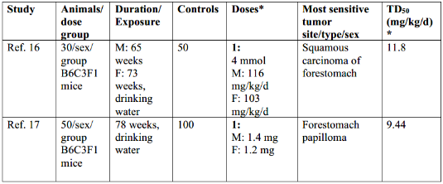  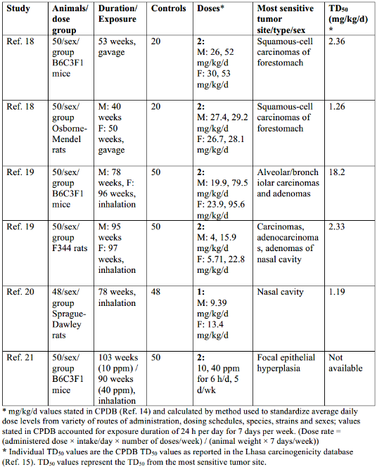
 | Mode of action for carcinogenicity | 1,2-Dibromoethane is a mutagenic carcinogen, which is expected to be mutagenic based on an alkylating mechanism of action. Therefore, the acceptable intake can be calculated by linear extrapolation from the TD50. The tumor types with the lowest calculated TD50 (highest potency) for 1,2-dibromoethane following oral exposure are forestomach tumors in mice and rats (Ref 18). Following inhalation exposure, the lowest calculated TD50 values are associated with the lung and nasal cavity for mice and rats, respectively. High concentrations of orally dosed non-mutagenic chemicals have been shown to cause inflammation and irritation after contact with the forestomach leading to hyperplasia and ultimately tumors. Substances that are dosed by gavage can remain for some time in the rodent forestomach before discharge to the glandular stomach, in contrast to the rapid passage through the human esophagus. Hence, such tumor induction is considered not relevant to humans at non-irritating doses (Ref. 22, 23). The same inflammatory and hyperplastic effects are also seen with mutagenic chemicals. However, in the case of 1,2-dibromoethane, which is a directly DNA reactive alkylating agent and reported multi-site, multi-species carcinogen, it is difficult to discriminate between the contribution to mode of action of these non-mutagenic, high-dose effects compared with direct mutation induction.
 | Regulatory and/or published limits | No regulatory limits have been published.
 | Acceptable intake (AI) | Rationale for selection of study for AI calculation  1,2-Dibromoethane is a mutagenic carcinogen via the inhalation and oral routes of exposure. 1,2-Dibromoethane is considered to be a carcinogen in both mice and rats. The available toxicological data indicate that absorption of inhaled 1,2-dibromoethane occurs in several animal species. In rats, oral absorption has been shown to be nearly complete within 30 minutes (Ref. 1). Therefore, it can be reasonably assumed that complete systemic exposure to 1,2-dibromoethane occurs following oral and inhalation exposure. This is also supported by the observation of distal tumors in animals exposed to 1,2-dibromoethane by both routes of exposure. TD50 values tend to be similar across species and route of administration.  The most appropriate and robust carcinogenicity data for derivation of an AI is the inhalation study conducted by the NTP (Ref. 19) in F344 rats. This study (duration 95 weeks in males and 97 weeks in females) included two test article treatment groups with adequate dose spacing (M: 4, 15.9 mg/kg/d, F: 5.71, 22.8 mg/kg/d with 50 rats/sex/group) and a control group (50/sex). Another study with inhalation exposure conducted in Sprague Dawley rats (Ref. 20) resulted in a lower TD50, however the study comprised only one dose group and only 78 weeks duration and 48 animals/dose and therefore was considered inferior to the NTP study with respect to AI calculation. Therefore, the TD50 value for the most sensitive species/sex/site of the most appropriate study is 2.33 mg/kg/d.  For the oral route of exposure the study in B6C3F1 mice with 1,2-dibromoethane administered by gavage for 53 weeks (Ref. 18) is the most extensive study. This study employed two test article dose groups (50 sex/group) in addition to a control group (20 sex). The TD50 from the most sensitive sex and site is 2.36 mg/kg/day. Another oral study was conducted in Osborne-Mendel rats including two dose groups, however due to insufficient dose spacing (Ref. 18) and less than one year exposure, the study is considered inferior as it limits characterization of the dose- response relationship and estimation of the TD50 (Ref. 18).  Taking into consideration the carcinogenicity data generated by NTP in both mice and rats, the TD50 for the most sensitive sex/site from the most appropriate study is 2.33 mg/kg/day. This is the TD50 value derived from F344 female rats based on the incidence of nasal cavity tumors (Table 1).  Given that the TD50 values recommended for the derivation of an inhalation AI and an oral AI are very similar (2.33 and 2.36 mg/kg/day, respectively), a single AI for both routes of administration is calculated below using a TD50 value of 2.3 mg/kg/day.
 | Calculation of AI | Lifetime AI = TD50/50000 x 50 kg  Lifetime AI = 2.3 mg/kg/day/50000 x 50 kg  Lifetime AI = 2 µg/day
 | References | 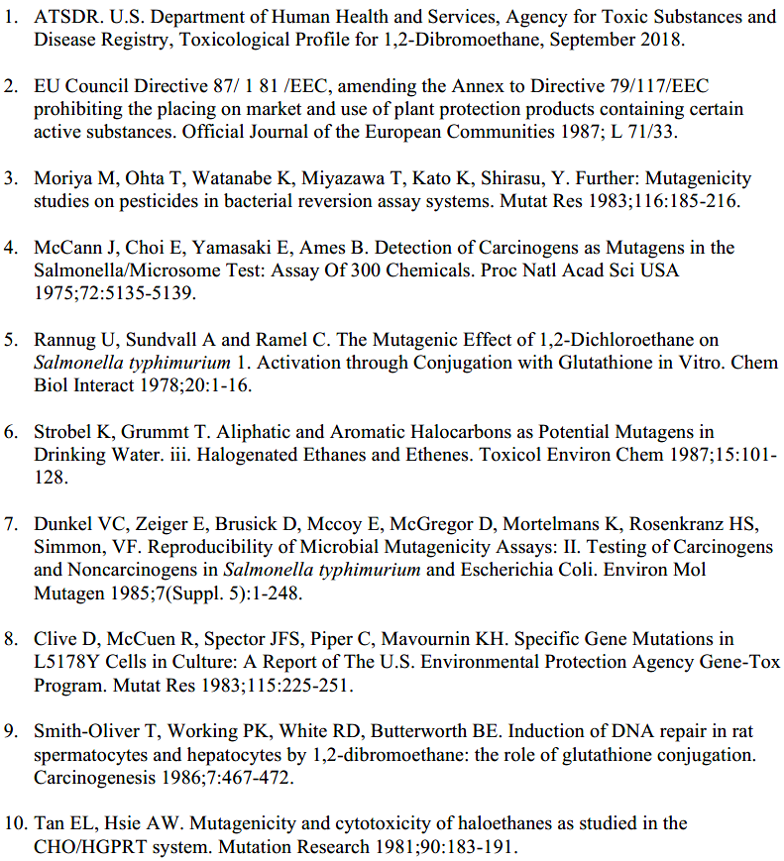  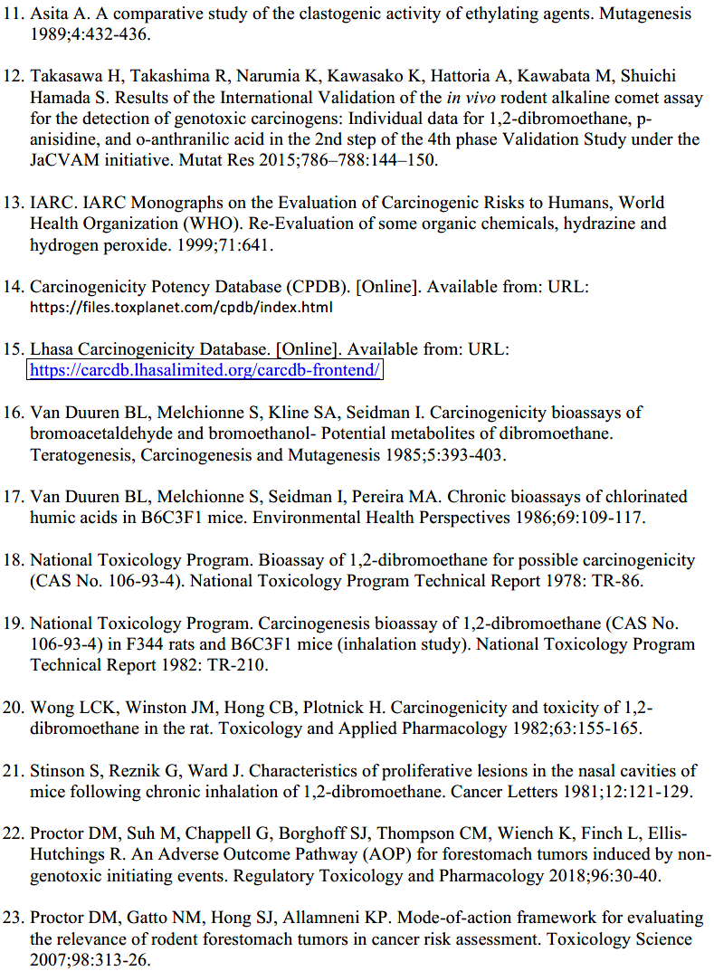
Epichlorohydrin (CAS# 106-89-8)
 | Potential for human exposure | Epichlorohydrin is used in the synthesis of active pharmaceutical ingredients.
 | Mutagenicity/genotoxicity | The genotoxicity of epichlorohydrin has been reviewed (Ref. 1-3). Epichlorohydrin is mutagenic and genotoxic in vitro, with mixed results of genotoxicity tests in vivo. While genotoxicity in vitro is seen both with and without liver S9 metabolic activation, activity tends to be suppressed by S9 (Ref. 3). Epichlorohydrin is mutagenic in several strains of Salmonella typhimurium and in Escherichia coli WP2 uvrA with and without metabolic activation using both plate incorporation and preincubation protocols (Ref. 4). In vitro, epichlorohydrin is positive in mammalian cells for mutation, and for chromosome and DNA damage.
 | Carcinogenicity | Epichlorohydrin is classified as a Group 2A carcinogen, probably carcinogenic to humans (Ref. 1). Epichlorohydrin is a site-of contact carcinogen, by oral, subcutaneous and inhalation routes.  In an oral study, Wester et al. (Ref. 5) treated rats by oral gavage with epichlorohydrin, 5 times per week for lifetime at 2 and 10 mg/kg, when converted to an average daily dose for 7 days per week, the doses shown in the CPDB (Ref. 6) are 1.43 and 7.14 mg/kg/d, respectively. In the surviving rats at the end of the study, squamous cell carcinomas were found in the forestomachs of all 24 females and 35 of 43 males at the high dose, and in 2 of 27 females and 6 of 43 males at the low dose. The tumors were considered low grade and there was no evidence of metastasis; no increase in tumors was found at other sites. At both dose levels, there were proliferative changes in the forestomach mucosa, in some cases with ulceration and necrosis at the high dose. A TD50 of 2.55 mg/kg/day is reported in the CPDB. The findings are consistent with the squamous cell carcinomas seen in forestomachs of male Wistar rats treated with epichlorohydrin in drinking water for up to 81 weeks (Ref. 7). The Konishi et al. study is not included in the CPDB and not considered in this monograph because of technical deficiencies, and poor condition of the animals.  In an inhalation study, Laskin et al. (Ref. 8) treated male Sprague Dawley rats with epichlorohydrin by inhalation, 6 hours/day, 5 days/week, either for a short-term regimen (30 exposures at 100 ppm) with lifetime observation (140 rats per group), or throughout lifetime at lower doses, 10 and 30 ppm (100 rats per group). After the shorter-term and high dose exposure, squamous cell carcinomas of the nasal cavity in 15/140 rats and respiratory tract papillomas in 3/140 rats were observed associated with severe inflammation in the nasal turbinates, the larynx and the trachea. After lifetime exposure, tumors were seen in 2/100 animals exposed to a dose of 30 ppm and only in the nasal cavity (1 nasal carcinoma and 1 nasal papilloma). Despite the low tumor incidence, a TD50 of mg/kg/day is reported in the CPDB.  In a subcutaneous study, Van Duuren et al. (Ref. 9) found sarcomas at the injection site after subcutaneous injection of epichlorohydrin in mice, but no increase in tumor incidence after dermal application, and weekly i.p. injections for over 64 weeks. Storrer et al. (Ref. 10) injected mice (AJ strain), with total doses of 20, 50 or 100 mg/kg epichlorohydrin given three times per week for eight weeks. There was a significant increase in the number of lung tumors in males treated with the highest dose (0.80 ± 0.68, compared with 0.47 ± 0.63 in controls; p < 0.01), but not in other groups.
 | Epichlorohydrin – Details of carcinogenicity studies | 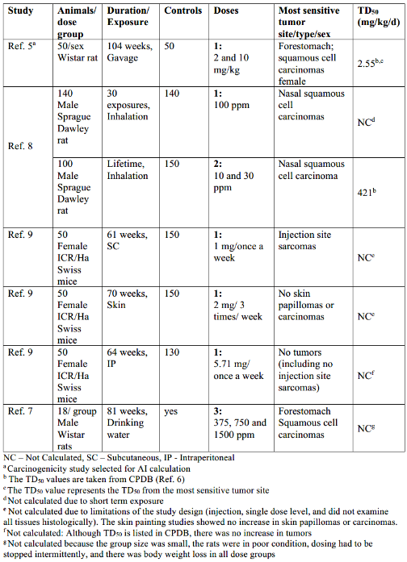
 | Mode of action for carcinogenicity | Epichlorohydrin caused tumors only at the site of contact; forestomach and oral cavity tumors after oral exposure, nasal tumors after inhalation and injection site sarcomas after subcutaneous injection.  Epichlorohydrin is mutagenic in vitro in bacteria and mammalian cells (Ref. 4). It is highly irritating to the exposed tissues. For example, dose-related lesions of the forestomach were observed in rats given epichlorohydrin by gavage at 3, 7, 19 and 46 mg/kg/day for 10 days, or 1, 5 and 25 mg/kg/day for 90 days (Ref. 11). There were a range of inflammatory and epithelial alterations; most pronounced were dose-related increase in mucosal hyperplasia and hyperkeratosis. Data indicate that epichlorohydrin is absorbed, and its metabolites enter systemic circulation; however, tumors are seen only at sites of direct contact. For more details on relevance of forestomach tumors see acrylonitrile and benzyl chloride monographs in the ICH M7 Addendum (ICH M7 (R1), 2018).
 | Regulatory and/or published limits | The World Health Organization (Ref. 12) has published a provisional total daily intake of 0.14 μg/kg/day or 8.4 μg/day (for a 60 kg adult), based on the assumption of a non-linear dose response for this site-of-contact carcinogen. The US EPA used linear extrapolation to derive a drinking water level (1 in 10⁵ risk of excess cancer) of 30 μg/L or about 60 μg/day (Ref. 13), using data from Konishi et al. (Ref. 7). US EPA also calculated an inhalation concentration of 8 μg/m³ for a 1 in 10⁵ excess cancer risk, or 230 μg/day, using ICH Q3C assumptions for human daily breathing volume (Ref. 13).  FDA/CFSAN calculated the Unit Cancer Risk of 2.7 x 10⁻³(mg/kg/day)⁻¹ using the data in Konishi et al. cited in the table above (Ref. 14). A food additive contaminant migrating into human food at an exposure of over 0.37 μg/kg or 22 μg/day would result in an estimated cancer risk over 1 in 10⁶ .
 | Acceptable intake (AI) | Rationale for selection of study for AI calculation  The oral gavage study of Wester et al. (Ref. 5) is the most robust study for calculation of the AI and the most sensitive species and tissue is rat forestomach in the gavage carcinogenicity study. The study included appropriate dose range for measuring tumor incidence demonstrating a clear dose response and provides sufficient data for the calculation of a compound specific AI.
 | Calculation of AI | Lifetime AI = TD50/50,000 x 50 kg  Lifetime AI = 2.55 mg/kg/day/50,000 x 50 kg  Lifetime AI = 3 µg/day
 | References | 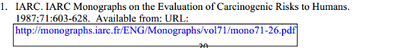  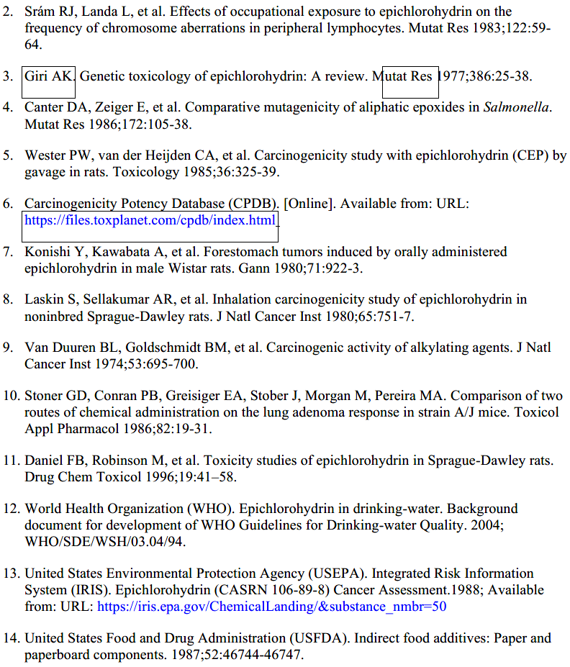
Ethyl bromide (CAS# 74-96-4)
 | Potential for human exposure | Ethyl bromide (bromoethane) is a colorless volatile and flammable liquid. It is an alkylating agent used primarily as a reagent in synthesis of pharmaceuticals. Its close analog, chloroethane, listed in M7, is a mutagenic carcinogen.
 | Mutagenicity/genotoxicity | Ethyl bromide is mutagenic per the principles of ICH M7 and genotoxic in vitro. The mutagenicity of ethyl bromide was evaluated in Salmonella tester strains TA 97, TA 98, TA 100 and TA 104, both in the presence and absence of added metabolic activation by Aroclor-induced rat liver S9 fraction (Ref. 1). Ethyl bromide is a volatile and hydrophobic compound, it was tested in both the standard Salmonella assay and in the same assay modified by incubation in a desiccator. In the standard assay, at concentrations of 5, 10, 50, 100, 500, and 1000 μg/plate ethyl bromide was not mutagenic. However, ethyl bromide was mutagenic in bacterial reverse mutation assays in Salmonella typhimurium TA98, TA100, TA104 with metabolic activation and mutagenic in TA 97 with and without metabolic activation. TA100, TA1535 and Escherichia coli WP2 with and without metabolic activation when tested as a gas in sealed desiccators (Ref. 2, 3).  In cultured CHO cells, ethyl bromide induced sister chromatid exchanges (SCEs) but not chromosomal aberrations in both the presence and absence of exogenous metabolic activation (Ref. 4).
 | Carcinogenicity | The IARC has determined that ethyl bromide is not classifiable as to its carcinogenicity to humans (Ref. 5). There is no epidemiological data relevant to carcinogenicity and limited evidence in experimental animals for the carcinogenicity of ethyl bromide.  In animals, evidence of carcinogenicity was identified from a 2-year bioassay from the National Toxicology Program (NTP) that evaluated the inhalation route of ethyl bromide administration in rats and mice. A variety of effects (dependent on species and sex) were seen with exposures of 100, 200, or 400 ppm 6 hours/day, 5 days/week (Ref. 3).  There was some evidence of carcinogenic activity of ethyl bromide for male F344/N rats, as indicated by increased incidences of pheochromocytomas and malignant pheochromocytomas, combined, of the adrenal medulla (control, 8/40; 100 ppm, 23/45; 200 ppm, 18/46; 400 ppm, 21/46). In female rats, the incidences of gliomas in the brain and adenomas in the lung were increased However, the incidence of the former was within historical control and the latter the incidence was not statistically significant by trend test or pairwise comparisons. For male B6C3F1 mice, there was equivocal but statistically significant increase in incidences of neoplasms of the lung (alveolar/bronchiolar adenomas or carcinomas). There was clear evidence of carcinogenic activity for female B6C3F1 mice, as indicated by neoplasms of the uterus (adenomas or adenocarcinomas).
 | Ethyl Bromide – Details of carcinogenicity studies | 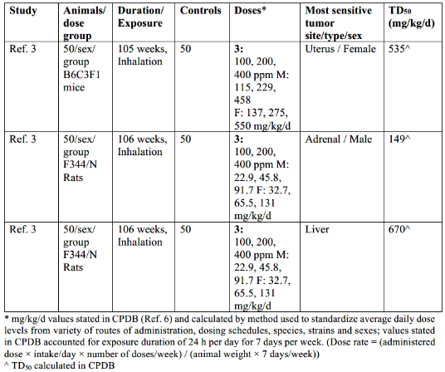
 | Mode of action for carcinogenicity | Ethyl bromide is an alkylating agent. It is a mutagenic carcinogen, and the acceptable intake is calculated by linear extrapolation from the TD50.
 | Regulatory and/or published limits | For ethyl bromide, the ACGIH threshold limit value-time-weighted average (TLV-TWA) for ethyl bromide is 5 ppm (22 mg/m³ ), while OSHA and NIOSH indicate the TWA as 200 ppm (890 mg/m³) (Ref. 7). The ACGIH estimates this value with a notation for skin absorption, but OSHA and NIOSH estimates are based on inhalation studies.
 | Acceptable intake (AI) | Rationale for selection of study for AI calculation  Ethyl bromide is a mutagenic carcinogen via the inhalation route of exposure. Although no information on the inhaled bioavailability of ethyl bromide was found, organic solvents have high inhalation bioavailability values (Ref. 8) and systemic exposure via inhalation route has been demonstrated in multiple studies by clinical observations (Ref. 9). Neoplastic lesions were observed in multiple organs where systemic exposure is indicated in mice and rats in addition to the site-of-contact tissues (e.g., lung). Therefore, it is reasonable to apply the AI derived from inhalation studies for other routes of administration.  Considering all the available data from the inhalation studies in rats and mice, the most sensitive tumor endpoint was the combined pheochromocytoma and malignant pheochromocytomas of the adrenal gland in male F344/N rats. The TD50 calculated by CPDB for this endpoint was, however, not statistically significant. This is due to the lack of a significant dose response trend test for the endpoint. However, calculating a TD50 for each dose separately results in statistically significant TD50 values for each dose (TD50 = 32.2 mg/kg/d for low dose, 115 mg/kg/d for mid dose, 162 mg/kg/d for high dose – Note 2). Therefore, the effect is considered relevant and the lowest TD50 value of 32.2 mg/kg/d is used as it was considered to conservatively yield the most sensitive potency estimate for calculating the AI.
 | Calculation of AI | Lifetime AI = TD50/50,000 x 50 kg  Lifetime AI = 32.2 mg/kg/day/50,000 x 50 kg  Lifetime AI = 32 µg/day
 | References | 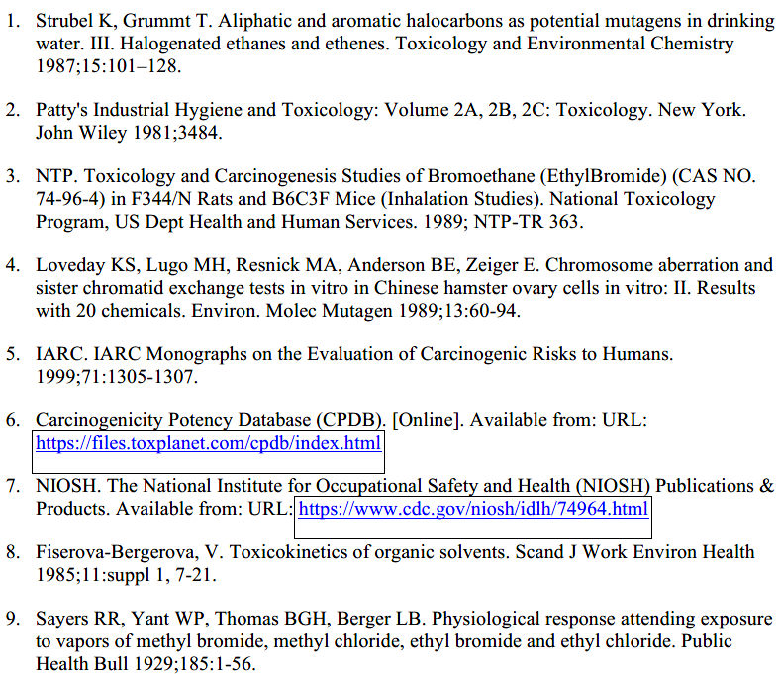
Formaldehyde (CAS# 50-00-0)
Potential for human exposure |  | Formaldehyde exposure occurs in air, water, and food, and is a common endogenous component of biological materials and is a naturally occurring component of many foods such as meat, dairy products, fruit and vegetables. Levels of daily exposure to formaldehyde via the dietary route have been estimated in the range of 1.5-14 mg/day (Ref. 1-3). Formaldehyde is also a product of normal human metabolism and is essential for the biosynthesis of certain amino acids. The human body produces and uses approximately 50 g of formaldehyde per day, which is rapidly metabolized and cleared from blood plasma (Ref. 3-5). Formaldehyde is used in the synthesis and formulation of pharmaceuticals. In some cases, formaldehyde can function as the active ingredient in a drug. Formaldehyde is also found as a component of some consumer products and can be produced during cooking or smoking.
Mutagenicity/genotoxicity |  | Formaldehyde is a mutagenic compound (Ref. 6). Formaldehyde induced mutations in the bacterial reverse mutation assay with and without S9 activation. It induced deletions, point mutations, insertions, and cell transformations in mammalian cells (Ref. 7). Formaldehyde is also clastogenic causing chromosomal aberrations, micronuclei, and sister chromatid exchanges in rodent and human primary cell lines. In vivo studies have also detected genotoxic effects primarily at the site of contact (Ref. 8).
Carcinogenicity |  | IARC considers formaldehyde to be a Group 1 carcinogen, or carcinogenic in humans based on cancer of the nasopharynx and leukemia (Ref. 6). There are several oral and inhalation animal studies (summarized in Table 1) conducted with formaldehyde. The carcinogenicity of formaldehyde is specific to inhalation and formaldehyde is not carcinogenic via the oral route (Ref. 6, 9-11).  Formaldehyde was negative in oral carcinogenicity studies in rodents. In carcinogenicity studies conducted by the inhalation route, tumors in the nasal cavity have been observed in rodents.  The nasal tumors observed following inhalation of formaldehyde were attributed to continuous cycles of tissue degeneration and regeneration (cytolethality/regenerative cellular proliferation; CRCP) rather than to a direct genotoxic effect (Ref. 12). Formation of DNA-protein crosslinks is probably involved in the cytolethality. Predicted additional cancer risks for an 80-year continuous environmental exposure to formaldehyde was modeled using CRCP. The risk predictions were obtained from what Conolly et al. (Ref. 12) expected to be significant overestimates of real-world exposures to formaldehyde.  Both IARC and US EPA concluded formaldehyde causes leukemia, in agreement with the conclusion of the NTP 14th Report on carcinogens that formaldehyde causes nasopharyngeal cancer and myeloid leukemia (ML), (Ref. 13). The conclusion that formaldehyde causes cancer was peer reviewed by the National Academy of Science (Ref. 14). The reviews acknowledged that hazard identification for formaldehyde was not straightforward, especially with respect to possible 796 leukemogenicity, in part due to its endogenous production and high reactivity. The most useful studies on the risk of formaldehyde causing ML are the large cohort studies of chemical workers and embalmers (Ref. 15). The conclusion was that there is a causal association between formaldehyde exposure and mortality from ML (Ref. 16). Albertini and Kaden (Ref. 17) concluded that overall, the available literature on genetic changes following formaldehyde exposure did not provide convincing evidence that exogenous exposure, and specifically exposure by inhalation, induces mutations as a direct DNA-reactive effect at sites distant from the portal-of- entry tissue. This would include proposed mode of actions that involve a stem cell effect at the port of entry with circulation back to the bone marrow. Such exposures have not been shown to induce mutations in the bone marrow or in any other tissues beyond the point of contact.  Since 2010, two short-term carcinogenicity studies have been conducted and published by the NTP in strains of genetically predisposed mice (male C3B6·129F1-Trp53tm1Brdp53 haplo-insufficient mice and male B6.129- Trp53tm1Brd) (Ref. 18). These short-term carcinogenicity studies were conducted to test the hypothesis that formaldehyde inhalation would result in an increased incidence and/or shortened latency to nasal and lymphohematopoietic tumors and to investigate hypotheses that formaldehyde may induce leukemia by a mechanism not involving DNA adduct formation. This proposed mechanism assumes that inhaled formaldehyde could cause significant genetic damage to stem cells in the nasal epithelium or circulating in local blood vessels. These damaged stem cells could reach the general circulation, undergo lodgment and become leukemic stem cells. The animals were exposed to 7.5 or 15 ppm formaldehyde 6 hours/day, 5 days/week, for 8 weeks and mice were monitored for approximately 32 weeks. At the highest concentrations, significant cell proliferation and squamous metaplasia of the nasal epithelium were observed; however, no nasal tumors were observed. No cases of leukemia were seen in either strain and a low incidence of lymphoma in exposed mice was not considered related to exposure. In addition, no significant changes in hematological parameters were noted. Under the conditions of these studies, the authors concluded that formaldehyde inhalation did not cause leukemia in these strains of genetically predisposed mice (Ref. 18).  Moreover, multiple studies in rats (Ref. 19-21) monkeys (Ref. 21, 22) conducted with sensitive analytical methods that can measure endogenous versus exogenous formaldehyde DNA or protein adducts have demonstrated that inhaled exogenous formaldehyde is not systemically absorbed or reaches sites distant from the point of initial contact. In addition to these studies, the available data on the toxicokinetics of formaldehyde suggest that no significant amount of “free” formaldehyde would be transported beyond the portal of entry.
Formaldehyde – Details of carcinogenicity studies |  | 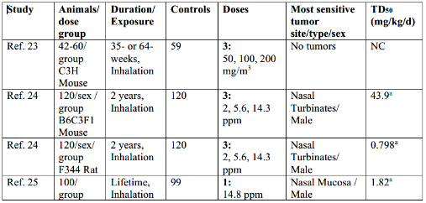  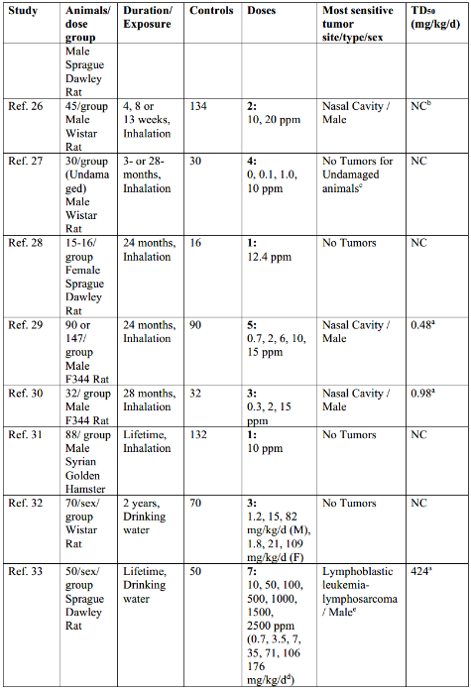  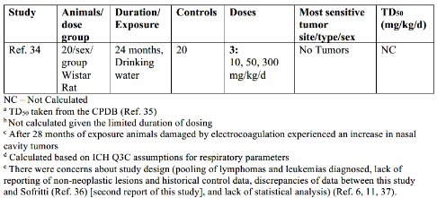
Mode of action for carcinogenicity |  | Formaldehyde was carcinogenic only in studies conducted by the inhalation route in rodents. Tumors in the nasal cavity have been observed and are considered a site of contact effect in rodents. The nasal tumors observed following inhalation of formaldehyde were attributed to continuous cycles of tissue degeneration and regeneration (cytolethality/regenerative cellular proliferation; CRCP) rather than to a direct genotoxic effect. Formation of DNA-protein crosslinks (DPX) is probably involved in the cytolethality of formaldehyde but not considered as the driving mechanism to carcinogenicity. In a recent review of the mode of action of formaldehyde and relevance of rat nasal tumors to humans, the role of cytotoxicity and regenerative cell proliferation was reaffirmed. The authors also indicate that although DNA-protein crosslinks are a good biomarker of exposure, they may not meaningfully contribute to cancer via genotoxic effects except at concentrations that result in tissues levels well above endogenous levels (Ref. 38).
Regulatory and/or published limits |  | For oral exposure to the general population, the ATSDR, Health Canada, International Programme on Chemical Safety (IPCS), and US EPA limit for formaldehyde is 0.2 mg/kg/day or 10 mg/day for a 50 kg person, which is based on a non-cancer endpoint (reduced weight gain and histological changes to the gastrointestinal tract and kidney) (Ref. 39-41). No oral carcinogenicity risk estimates have been performed with formaldehyde, since carcinogenicity is specific to the inhalation route of exposure.  Occupational limits have been set for air at work places by NIOSH (REL TWA 0.016 ppm), ACGIH (TWA 0.1 ppm), DFG MAKs (TWA 0.3 ppm), and OSHA (PEL TWA 0.75 ppm).  For inhalation exposure to the general population, the US EPA, IPCS, and Health Canada have developed inhalation cancer risk values (Ref. 11, 40, 41). The US EPA limit is based on a linear cancer model, and Health Canada/IPCS developed nonlinear and linear cancer models. Using the linear method from all three agencies, a daily inhaled dose of 16-32 µg/day would result in a 1 in 10⁵ excess risk of cancer. However, more recent scientific analysis supports the use of the Health Canada/IPCS nonlinear model, which incorporates mechanistic data (Ref. 42-44). Conolly et al. (Ref. 12) developed a nonlinear / linear mechanistic-based model using empirical rodent and human data for the two modes of action with formaldehyde tumorigenicity: CRCP and DNA- protein cross-links (DPX).
Acceptable intake (AI) for inhalation exposure |  | Rationale for selection of study for AI calculation  The AI for inhalation is based on the carcinogenicity model developed by Conolly et al. (Ref. 12). Figure 1 represents the dose-response hockey stick-shaped model developed by Conolly et al., (Ref. 12) for a mixed population of smokers and non-smokers. The rat dose response for CRCP/DPX was used by Connolly for the human model in absence of an alternative model. Since the exposure related tumor risk predicted by clonal growth models was extremely sensitive to cell kinetics, Conolly et al. decided to evaluate human cancer risk associated with formaldehyde exposure using both the raw J-shaped dose-response and a hockey stick–shaped transformation of the rat data. This model incorporates the non-linear-based mechanism at the high dose region (CRCP) and the linear mechanism at the low dose region (DPX). As noted above, the translation of DPX into mutations and an assumed linear-dose response emerging from such mutations is not established experimentally. Moreover, experimental results suggest that DPX are not leading to mutations in a linear fashion. Thus, the linear dose-response model at low doses reflect a conservative and practical approach and is not dictated by experimental data.  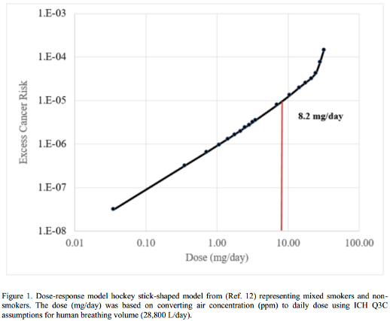
Calculation of inhalation AI |  | The linear low dose region of Figure 1 was used to determine the dose at a 1 in 100,000 excess cancer risk. Linear regression at the low dose region, which is ≤ 24.74 mg/day (converted from 907 0.7 ppm) results in an equation of y = 1.62E-06x – 3.27E-06. The dose of 24.74 mg/day was the point at which there is a predicted upward inflection of additional risk. Solving for a 1 in 100,000 excess cancer risk in the regression line (y) results in an acceptable intake of 8.2 mg/day (see Figure 1 dose equivalent to the 1:100,000 risk).  Risk (y) = 1.62E-06x(dose) – 3.27E-06  0.00001 = 1.62E-06x – 3.27E-06  x = (0.00001 + 3.27E-06) / 1.62E-06  Dose (x) = 8.2 mg/day
Lifetime AI (inhalation) = 8 mg/day or 215 ppb, whichever is lower |  | *Formaldehyde is considered a mutagenic carcinogen by the inhalation route of exposure. The acceptable intake of 8 mg/day represents an upper limit over a 24 hour time period. As described in the introduction section of Appendix 3 of this guideline, “other considerations” may affect final product specifications. WHO recommends a limit of 77 ppb in air as a 30 min average and Health Canada recommends a short-term exposure limit of 100 ppb based as a 1 hour average. These recommended values provide at least a 10-fold margin of exposure to the lowest level at which symptoms were observed. To protect patients from the local irritation and sensitization effects of formaldehyde by the inhalation route of exposure, a lower concentration-based limit of 215 ppb is recommended [8 mg/day over 24 hours of exposure is equal to a concentration limit of 215 ppb (0.008 g/day / 28.8 m³/day) * 1 / 1293 g/m³ )].  human breathing volume/d - 28.8 m³  air mass/m³ at standard conditions - 1293 g
Permissible Daily Exposure (PDE) for all other routes |  | See section 4 of the introduction to this Addendum that addresses formaldehyde exposure from the environment.  PDE (all other routes) = 10 mg/day
References |  | 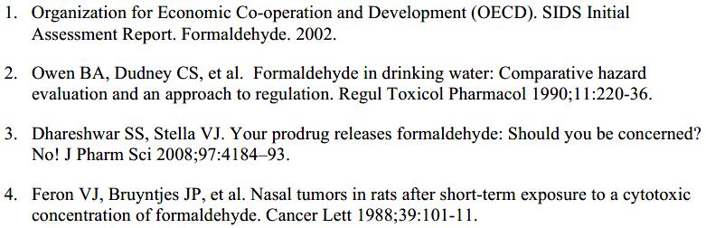  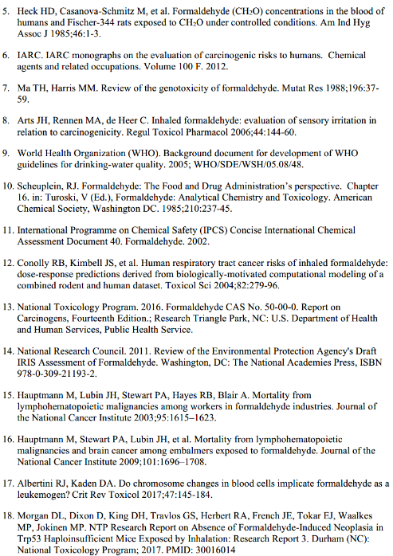  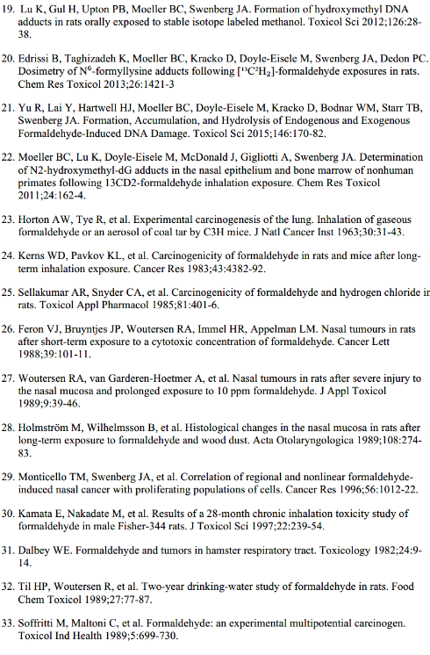  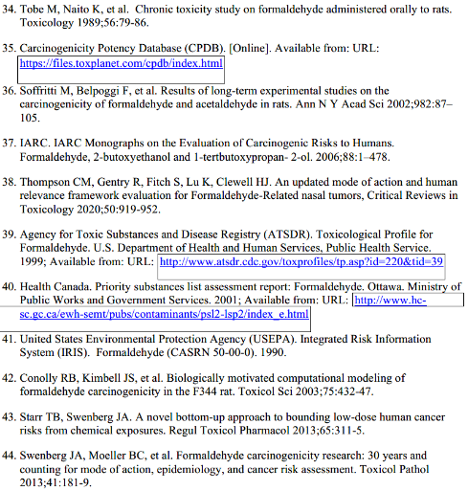
Styrene (CAS# 100-42-5)
Potential for human exposure |  | Styrene exposure to the general population occurs via environmental contamination and dietary exposure (Ref. 1). In the general population, indoor and outdoor air account for the largest exposures. However, smoking one pack of cigarettes would likely lead to the inhalation of milligram quantities of styrene (Ref. 2). Styrene has been detected as a natural constituent of a variety of foods and beverages, the highest levels occurring in cinnamon. Polystyrene and its copolymers are widely used as food-packaging materials and monomers such as styrene can migrate to food at low levels. The daily intake of styrene from dietary sources has been estimated to be 1-4 μg in the United Kingdom, 2-12 μg in Germany and 9 μg in the United States (Ref. 3, 4). Styrene is used in the synthesis of active pharmaceutical ingredients.
Mutagenicity/genotoxicity |  | Styrene has produced contradictory findings in the in vitro bacterial reverse mutation assay and it is predominantly inactive in the in vivo chromosome aberration, micronucleus and UDS assays when conducted according to OECD guidelines. Inconsistent results in the bacterial reverse 1069 mutation (Ames) test were attributed to styrene volatility, poor solubility, and different metabolic systems (Ref. 5). Styrene was positive for mutagenicity in the Ames test only with metabolic activation (Ref. 5), where it is converted to electrophilic intermediates (e.g., styrene 7,8-oxide) to enable formation of covalent adducts with DNA. The main metabolite of styrene is styrene 7, 8-oxide. Most of the genetic damage associated with styrene exposure is thought to be due to styrene 7, 8-oxide, which is further detoxified to styrene glycol. Styrene exposure elevated DNA adducts (N7-guanine, O6-guanine, and N1-adenine) and SCEs in both animal models and in humans, and DNA strand breaks in humans (Ref. 5, 6). In a critical review of styrene genotoxicity based on the requirements outlined in the current OECD guidelines, Moore et al. (Ref. 7) concluded that it is unclear whether unmetabolized styrene is mutagenic in the Ames test, while the styrene 7, 8-oxide metabolite is clearly mutagenic. The authors also noted that most styrene 7, 8-oxide Ames positive data was collected without using exogenous metabolic activation, meaning that styrene 7, 8-oxide was not further metabolized to styrene glycol.  Styrene was mutagenic in glycophorin A (GPA) variant frequencies in erythrocytes from 28 workers inhalation-exposed to ≥ 85 mg/m³ styrene (Ref. 8). Lymphocytes from styrene exposed workers had increased mutation frequencies (MFs) at the HPRT locus (Ref. 9).  Two in vitro mammalian gene mutation studies were identified. In the hypoxanthine-guanine phosphoribosyl transferase (Hprt) assay, styrene induced only small increases in HPRT MFs in V79 cells (Ref. 10). Similarly, in V79 cells, styrene induced small increases in Hprt MFs with large variability observed in a liver perfusion system and little to no increases with or without S9 (Ref. 11). No rodent in vivo mutation studies evaluating styrene or styrene 7, 8-oxide were identified.  Based on standard regulatory tests, there is no convincing evidence that styrene possesses significant genotoxic potential in vivo from the available data in experimental animals. However, genotoxicity associated with styrene exposure (related to formation of styrene-7, 8-oxide) has been proposed as a possible mode of action for styrene induced carcinogenicity in experimental animals and humans (Ref. 1).
Carcinogenicity |  | The IARC has classified styrene and the metabolite styrene 7,8-oxide in Group 2A, “probably carcinogenic to humans based on limited evidence in humans and sufficient evidence in experimental animals” (Ref. 5). Styrene is also reasonably anticipated to be a human carcinogen by the NIH (Ref. 1). Possible modes of action for styrene-induced carcinogenicity involve genotoxic and cytotoxic effects together with immunosuppression (Ref. 1). NTP listed styrene as “reasonably anticipated to be a human carcinogen” in its 12th and 14th Reports on Carcinogens (Ref. 12, 13). The NRC concluded “reasonably anticipated to be a human carcinogen” was an appropriate carcinogenicity classification for styrene, due to limited carcinogenicity evidence in humans, sufficient evidence in animal studies, and other mechanistic data supporting carcinogenicity (Ref. 6).  A recent systematic review of epidemiologic studies of exposure to styrene concluded that besides some limitations of available research as lack of quantitative estimates of styrene, the risk of specific cancers found no strong and consistent evidence of a causal association between styrene and Non-Hodgkin lymphoma and its subtypes, all leukemia, subtypes of leukemia or cancers of the esophagus, pancreas, lung, kidney or other sites (Ref. 14).  In the CPDB, styrene is reported to be carcinogenic in mice via the oral and inhalation routes and rats via the inhalation route (Ref. 15). The National Institutes of Health Report on Carcinogens (Ref. 1) considered the most robust studies to be the two-year studies via (1) oral exposure in B6C3F1 mice and (2) inhalation exposure in CD-1 mice. In male B6C3F1 mice, oral exposure to styrene increased the combined incidence of alveolar and bronchiolar adenomas and carcinomas (Ref. 16). In the inhalation study, in male and female CD-1 mice, there was an increase in the incidence of pulmonary adenomas and also an increase in pulmonary carcinomas in females in the high-dose group (Ref. 17).  IARC evaluated nine studies each (with various routes of application) in mice and rats for styrene and three each in mice and rats for styrene-7,8-oxide. For styrene in mice in one study with transplacental exposure followed by gavage using O20 mice, an increase of lung carcinoma and adenoma was observed in pups whereas a second study in C57BL mice was negative (Ref. 18). Two out of five studies with inhalation in mice reported an increase in lung bronchoalveolar tumors in CD-1 mice (Ref. 16, 19) whereas the other three (in C57BL/6 mice) were negative (Ref. 19). One study with oral application found increased lung tumors and a positive trend for hepatocellular carcinoma (Ref. 16). One study with i.p. application gave negative results (Ref. 20). In two studies in SD-rats with inhalation exposure, styrene increased mammary gland tumors (Ref. 21, 22), whereas four oral studies, three with gavage (Ref. 17, 22) and one via drinking water (Ref. 23), were negative as well as one study with transplacental exposure followed by gavage (Ref. 17), one study with i.p. application and one with s.c. application (Ref. 22). Styrene-7-8-oxide was tested in three studies in mice, one by gavage (Ref. 24) and two by skin application (Ref. 25, 26). In the oral study by gavage styrene-7-8-oxide increased squamous cell tumors in forestomach in males and females and hepatocellular tumors in males. The studies by skin application were inadequate for evaluation. In rats, styrene-7-8-oxide was tested in two studies with oral exposure by gavage (Ref. 22, 24) and one by transplacental exposure followed by gavage (Ref. 27). In both studies by gavage, squamous cell tumors of the forestomach were increased and in one of the studies mammary gland tumors where also increased in males. In the study by transplacental exposure followed by gavage, forestomach tumors where increased. IARC concluded that there is sufficient evidence for carcinogenicity of styrene and styrene-7,8-oxide in experimental animals (Ref. 5).  US NTP concluded that the evidence from studies in rats was insufficient for reaching a conclusion concerning the carcinogenicity of styrene (Ref. 1). An evaluation of the available data from eight oncogenicity studies by Cruzan et al., (Ref. 21) concluded that there was clear evidence that styrene did not induce cancer in rats. It has been proposed that the reason for lung tumor induction in mice but not rats may involve differential metabolism of styrene in the two species (Ref. 1).
Styrene – Details of carcinogenicity studies |  | 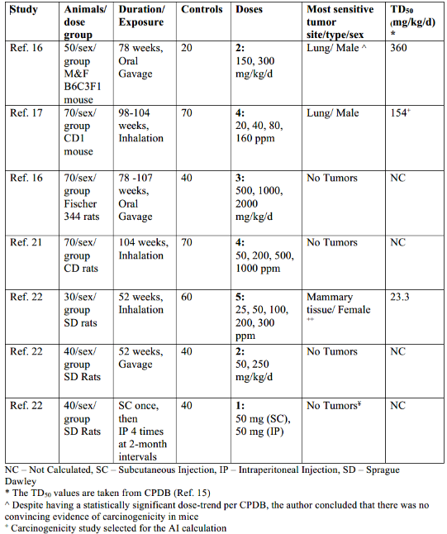  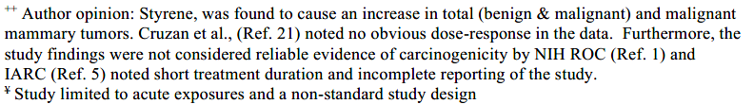
Mode of action for carcinogenicity |  | A comprehensive review of the mechanisms that contribute to the carcinogenicity of styrene is presented in the IARC Monograph (Ref. 5). Taking into consideration the available in vitro and in vivo genotoxicity data, IARC concludes that there is strong evidence that styrene is genotoxic, and that the mechanism is relevant to humans. Styrene is metabolically activated in animals and in humans to an electrophile, styrene-7,8-oxide which interacts with nucleophilic macromolecules, such as proteins and DNA. DNA adducts are formed primarily by alkylation of N⁷-guanine. Styrene-7,8-oxide DNA adducts have been observed in vitro, in rodents and in humans exposed to styrene. IARC also indicates that there is strong evidence that both styrene and styrene-7,8-oxide alter cell proliferation and that styrene modulates receptor-mediated effects based on increased serum prolactin in humans exposed occupationally.  Other possible mechanisms contributing to the carcinogenic activity of styrene include oxidative stress, immunosuppression and chronic inflammation. The mechanism suggested by Cruzan et al. (Ref. 28) as main cause of mice lung tumor includes styrene metabolites inducing gene expression for metabolism of lipid, lipoprotein, cell cycle and mitotic M-M/G1 phases, mild cytotoxicity and strong mitogenicity in mice lung cells, leading to excessive cell proliferation and hyperplasia. On the other hand, authors assume that it would not be relevant in humans due to limited lung metabolism (by CYP2F2). IARC concludes that the evidence for these mechanisms of action are moderate to weak.
Regulatory and/or published limits |  | The WHO defined a Tolerable Daily Intake (TDI) for styrene via the oral route of 7.7 µg/kg/day (i.e., 0.385 mg per day based on 50 kg body weight) from which a drinking water guideline value of 20 µg/L has been defined (i.e., 40 µg per day based on consumption of 2 L water per day) (Ref. 29). This WHO limit was based on reduced body weight gain in a two-year rat drinking water study. The US EPA oral reference dose (RfD) (Ref. 30) for styrene is 200 µg/kg/day (i.e., 10 mg/day based on 50 kg body weight), based on non-cancer endpoints. The associated US EPA drinking water limit is 100 µg/L (i.e., 200 µg per day based on consumption of 2 L water per day). The JECFA maximum TDI for styrene (Ref. 31) from migration from food packaging is 0.04 mg/kg/day (i.e., a maximum of 2 mg per day based on 50 kg body weight). A Specific Migration Limit of 60 ppm styrene into foods in polystyrene packaging (i.e., 60 mg per day assuming the consumption of 1 kg food/day for adult humans) is considered permissible in the European Union (Ref. 4).
Acceptable intake (AI) |  | Rationale for selection of study for AI calculation  Since styrene is considered not to be a rat carcinogen, mouse lung tumors were used to derive the AI. The more sensitive TD50 was in the inhalation study of Cruzan et al. (Ref. 17). The AI derived from this inhalation study was considered suitable for all routes of administration as an increase in lung tumors were also seen in the carcinogenicity study in mice with gavage treatment. The AI is expected to be a conservative limit as the mouse is known to have higher levels of CYP2F enzymes in comparison to human which is key to tumor formation (Ref. 28).
Calculation of AI |  | Lifetime AI = TD50/50000 x 50 kg  Lifetime AI =154 mg/kg/day/50000 x 50 kg  Lifetime AI = 154 µg/day
References |  | 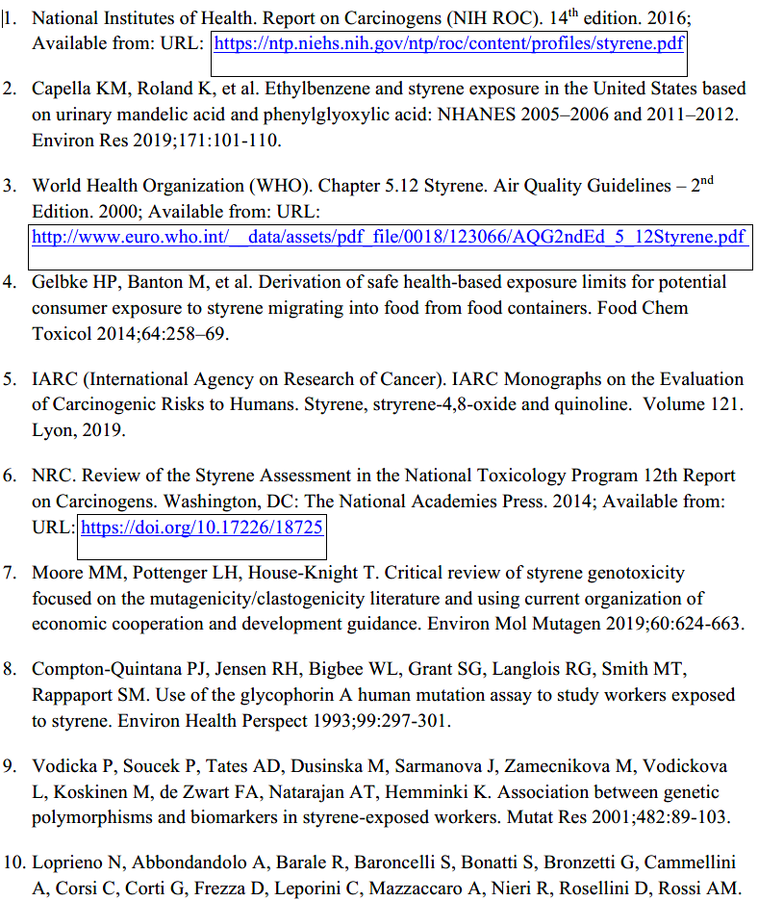  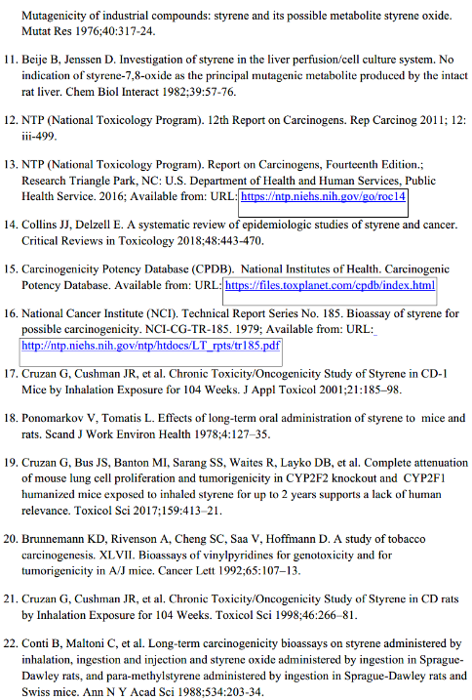  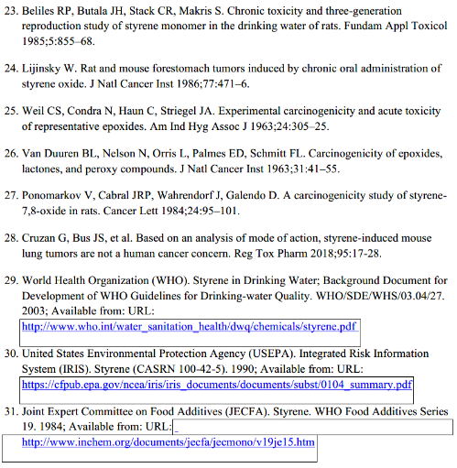
Vinyl Acetate (CAS# 108-05-4)
Potential for human exposure |  | Human exposure occurs primarily in the occupational setting with very little exposure to vinyl acetate in the general population (Ref. 1). Vinyl acetate is used in the synthesis of pharmaceuticals.
Mutagenicity/genotoxicity |  | The mutagenicity and genotoxicity of vinyl acetate has been reviewed by Albertini (Ref. 2). Vinyl acetate is not mutagenic in the microbial reversion assay (i.e., Ames tests) in multiple strains of Salmonella or in Escherichia coli and vinyl acetate mutagenicity in mammalian cells (at the tk locus human TK6 cells) appears to reflect mainly chromosome level or large mutational events, but “normal growth” mutants thought to reflect smaller, gene mutations were also reported. Vinyl acetate also induced micronuclei and chromosome aberrations in vitro and chromosome aberrations in vivo and was positive in one out of five in vivo micronucleus studies. Small increases of micronuclei in mouse bone marrow were induced following i.p. administration, but the genotoxicity was associated with elevated toxicity and mortality (Ref. 3).  There is extensive evidence that vinyl acetate genotoxicity is mediated by its metabolite acetaldehyde. Acetaldehyde is produced endogenously and detoxification by aldehyde dehydrogenase is required to maintain intra-cellular homeostasis (Ref. 2). Given its response in mammalian cells, and rapid conversion to acetaldehyde, vinyl acetate is considered mutagenic. See Mode of Action information below for further details.
Carcinogenicity |  | Vinyl acetate is classified as Group 2B, possibly carcinogenic to humans (Ref. 4). There are two oral carcinogenicity reports cited in the CPDB (Ref. 5). One mouse and one rat study, in which vinyl acetate was administered in drinking water, are limited as there are only two treatment groups and less than 50 animals per group. Uterine, esophageal and forestomach tumors were observed in Swiss mice; and liver, thyroid and uterine tumors in Fisher rats. A number of non-site of contact tumors (e.g., Zymbal gland, lung, liver, uterine, and mammary gland) were observed in the oral carcinogenicity studies conducted by Maltoni et al. (Ref. 6) and Lijinsky et al. (Ref. 7). These tumors in Maltoni et al. (Ref. 6) all occurred with high background incidence. Therefore, without adjusting for age, these tumor data cannot be evaluated with certainty. Squamous cell carcinoma of the oral cavity, tongue, esophagus, and forestomach were all treatment related at 5000 ppm. There were no tumors among mice administered 1000 ppm (Ref. 8). In the oldest published oral carcinogenicity study, Lijinsky et al. (Ref. 7) there are a number of deficiencies in the study design, most notably that the drinking water solutions were prepared only once per week. The authors recognized a decomposition rate of approximately 8.5% per day. Therefore, by the end of the week the animals in the 2500 ppm group, for example, were exposed to approximately 1300 ppm vinyl acetate and significant quantities of breakdown products, including acetaldehyde and acetic acid. The authors also did not purify the vinyl acetate prior to preparation of the drinking water solutions. Thus, the rats were also exposed to unspecified impurities. In addition, only 20 rats were in each group, so the statistical power for detecting true positive responses and for discriminating against false positive and false negative outcomes is compromised (Ref. 8).  In addition to the CPDB, other carcinogenicity studies are available in the literature. An oral drinking water study was conducted by the Japan Bioassay Research Centre in accordance with OECD guideline 453, including 3 treatment groups and 50 animals per group (Ref. 9, 10). Increases in tumors of the oral cavity, esophagus and forestomach in Crj:BDF1 mice and statistically significant increases of tumors in the oral cavity of female F344:DuCrj rats at all 1366 doses are reported following drinking water administration of vinyl acetate. In another lifetime study, Minardi et al. (Ref. 11) report increases in tumors in oral cavity and lips in 17-week old and 12-day old Sprague-Dawley rats also administered vinyl acetate in the drinking water. Two treatments groups are included with more than 50 animals per group for the 12-day old rats (offspring) but less than 50 per group for the 17-week old animals (breeders). The 12-day old rats are more sensitive with tumors in the oral cavity and lips, whereas an increase tumor response is not evident in the 17-week old animals.  Finally, Bogdanffy et al. (Ref. 12) administered vinyl acetate in drinking water for 10 weeks to male and female rats that were subsequently mated. The offspring were then culled into two groups of 60 for the main study and 30 for satellite groups and exposure in the drinking water continued to 104 weeks. The authors concluded that in the offspring there were no non-neoplastic or neoplastic lesions observed that were compound related. Two squamous carcinomas were observed in the oral cavity of treated males, but the incidence of these tumors was within historical control ranges. Therefore, they were not considered related to vinyl acetate treatment.  There are two inhalation carcinogenicity reports cited in the CPDB (Ref. 5). Vinyl acetate is not carcinogenic to CD-1 mice but induces nasal tumors in Sprague-Dawley rats (Ref. 12). All but one of the 11 nasal tumors in rats (benign endo and exophytic papillomas and squamous-cell carcinomas) were observed at the terminal sacrifice at the high dose of 600 ppm, indicating a late life dependency of tumor formation. One benign tumor, of questionable relationship to exposure, was observed at the 200 ppm concentration (Ref. 12). In both species and both sexes, vinyl acetate induced morphological non-neoplastic lesions in the nasal cavity of the 200 and 600 ppm groups and in the trachea (mice only) and in the lungs of the 600 ppm groups.
Vinyl Acetate – Details of carcinogenicity studies |  | 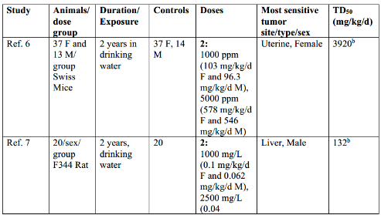  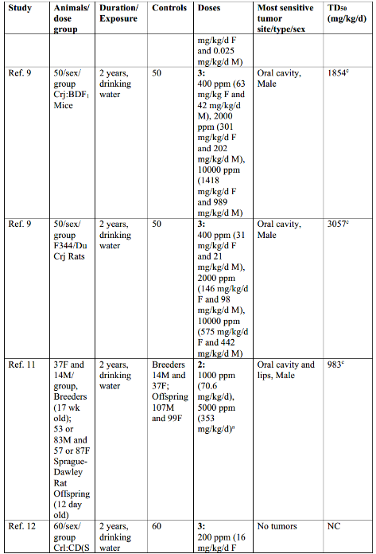  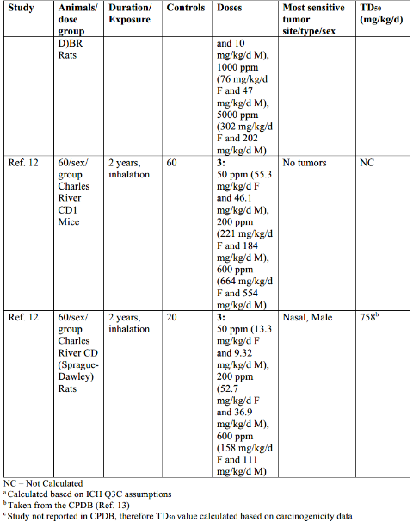
Mode of action for carcinogenicity |  | Vinyl acetate has been reviewed by the European Commission’s Scientific Committee on Health and Environmental Risks (SCHER), who published a Risk Assessment Report in 2008 (Ref. 1). Overall, SCHER supports the conclusion that the carcinogenic potential of vinyl acetate is expressed only when tissue exposure to acetaldehyde is high and when cellular proliferation is simultaneously elevated. This mode of action suggests that exposure levels, which do not increase intracellular concentrations of acetaldehyde will not produce adverse cellular responses. As long as the physiological buffering systems are operative, no local carcinogenic effect by vinyl acetate should be expected at the NOAEL for histological changes in respiratory rodent tissues. However, the SCHER indicated that local levels at or below the NOAEL are not free of carcinogenic risk, although the risk may be negligibly low. Hengstler et al. (Ref. 8) presented the case for vinyl acetate as a DNA-reactive carcinogen with a threshold dose-response, which has also been described by Albertini (Ref. 2). Like acetaldehyde, vinyl acetate is not-mutagenic in the standard bacterial reversion assay; evidence for DNA-reactivity and site of contact carcinogenicity of vinyl acetate is that it occurs because of metabolic conversion to acetaldehyde.  The genotoxicity profiles for acetaldehyde and vinyl acetate are almost identical and vinyl acetate is not active as a clastogen without the addition of carboxylesterase (Ref. 8). Therefore, the clastogenic activity of vinyl acetate is attributed to metabolic formation of acetaldehyde. At high concentrations, enzyme activities are not able to oxidize all the generated acetaldehyde, and a low pH microenvironment is the result (Ref. 12). From consistent endogenous acetic acid exposure, tissues may sustain a reduction of 0.15 units in pH following vinyl acetate treatment without adverse effects (i.e. cytotoxicity and genotoxicity) (Ref. 14). However, when this practical threshold is exceeded, DNA damage, cytotoxicity, and regenerative cellular proliferation occur, resulting in tumor formation at the site of contact.  There is clear evidence for the carcinogenicity of vinyl acetate in two animal species, in both sexes and for both inhalation and oral administration. Following both oral and inhalation administration, vinyl acetate is rapidly hydrolyzed at the site of contact by carboxylesterases, to acetic acid and acetaldehyde (Ref. 3, 15). Vinyl acetate exposure produces tumors at the site of first contact along the exposure routes. The dose-response is thought to be non-linear, with the observed tumor responses reflecting the target tissue-specific enzyme activities for activation and detoxification (Ref. 2). However, as noted in the acetaldehyde monograph, there are no published measurements which would allow discrimination between the irritating effect and the potential mutagenic effect ion cancer development.
Regulatory and/or published limits |  | For vinyl acetate, the US EPA IRIS database calculated an inhalation Reference Concentration (RfC) for non-carcinogenic effects of 0.2 mg/m³ , or 5.8 mg/day assuming a respiratory volume of 28.8 m³. The RfC was based on a human equivalent concentration of 5 mg/m³ derived from Owen et al. which identified both a NOAEL and a LOAEL for histopathological effects of the nasal olfactory epithelia in rats and mice in a chronic 2-year study. A total adjustment factor of 30 was applied (Ref. 16). The US EPA report did not include a carcinogenicity assessment for lifetime exposure to vinyl acetate. It is stated that RfCs can be derived for the noncarcinogenic health effects of substances that are carcinogens and to refer to other sources of information concerning the carcinogenic potential.
Permissible Daily Exposure (PDE) for oral exposure |  | Rationale for selection of study for PDE calculation  Following oral administration, vinyl acetate is rapidly hydrolyzed at the site of contact by carboxylesterases, to acetic acid and acetaldehyde. Given the weight of evidence for a non-linear dose response for the carcinogenicity of both vinyl acetate and acetaldehyde following oral administration and considering high background exposure to acetaldehyde from a wide variety of foods, the oral PDE recommended is based on that derived for acetaldehyde of 2 mg/day.  PDE (oral) = 2 mg/day
Acceptable intake (AI) for all other routes |  | Rationale for selection of study for AI calculation  For routes of administration other than the oral route, the inhalation carcinogenicity study in rats (Ref. 12) was used for derivation of an AI. In this study, there were 3 treatment groups with 60 animals per sex per treatment group. Animals were exposed 6 hours per day, 5 days per week for 2 years to vinyl acetate. Carcinogenicity was observed in the nasal cavity of rats, with male being the more sensitive sex. The TD50 for the nasal cavity in male rats is 758 mg/kg/day, as reported in CPDB. The only other carcinogenicity study that is available with vinyl acetate administered via the inhalation route in mice is negative (Ref. 12). Therefore, the rat inhalation study was selected for derivation of an AI.  Although the dose-response relationship for carcinogenicity is thought to be non-linear, as stated above, there are no published measurements which allow discrimination between a true threshold versus a non-linear inflection point. Therefore, the AI was calculated using linear extrapolation.
Calculation of AI |  | Lifetime AI = TD50/50000 x 50 kg  Lifetime AI = 758 mg/kg/day x 50 kg  Lifetime AI (all other routes) = 758 µg/day
References |  | 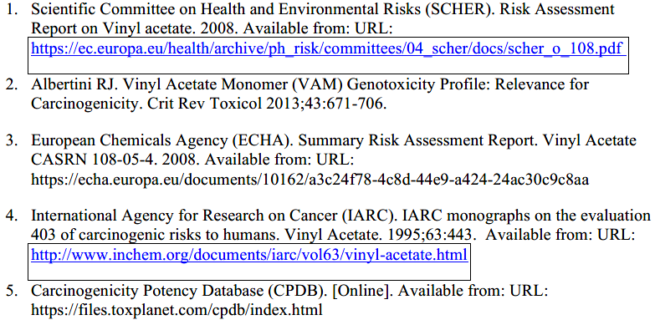  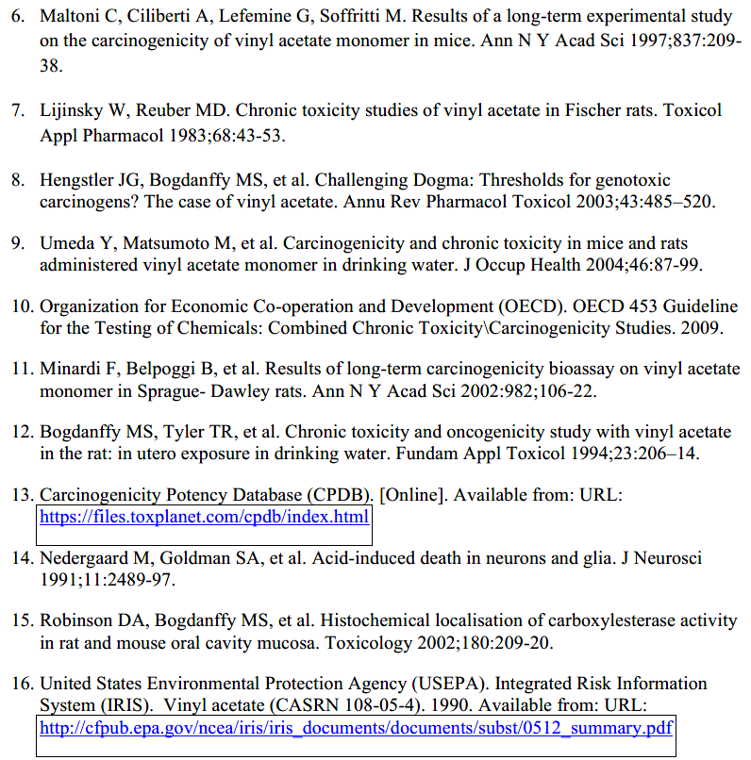
Note 2
The calculated TD50 for ethyl bromide is illustrated below since it was decided to use the same study data but not the TD50 calculated by CPDB as the positive dose response was not statistically significant (see monograph for ethyl bromide).
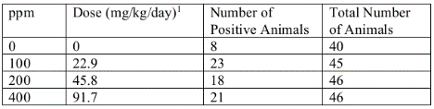

A TD50 is calculated for each dose separately with the following equation (Ref. 1, 2):
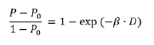

Where P is the proportion of animals with the specified tumor type observed at a certain dose (D in the equation) and P0 is the proportion of animals with the specified tumor type for the control. Converting β and D into a simple linear equation results in the following:
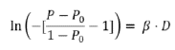

Plotting the results and using the slope to represent β results in the following graphs for the dose-response and β = 0.0215055234 for low dose, 0.0059671034 for mid-dose and 0.0042161616 for the high dose.

Low Dose
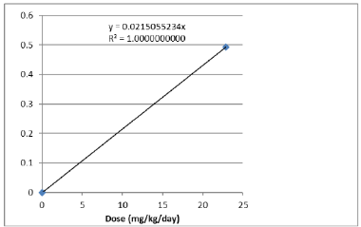

Mid Dose
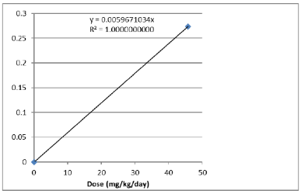

High Dose
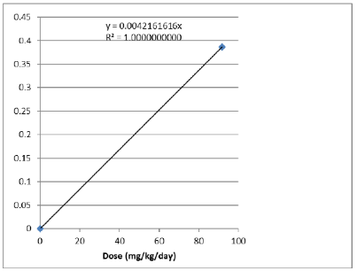

The TD50 can then be calculated as follows.
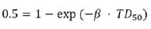

Solving for TD50 results in in the following equation.
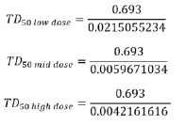
Therefore, the lowest TD50 = 0.693 / 0.0215055234 or 32.2 mg/kg/day.
References |  | 