ICH HARMONISED GUIDELINE
ICH Q3D (R2): Guideline for Elemental Impurities
(Draft version, Endorsed on September 25, 2020)
指引意見彙整表
段落 | 標題 | 內文 (摘自Q3D (R2) draft guideline，仍以ICH文件為準) | 相關建議及意見  (請提供中英文內容)
1. Part 1 - Q3D Appendix 2 Extract – Correction of PDEs for Gold, Silver and Nickel
Changes proposed to Appendix 2 are shown in track change, and are intended to be integrated into the Q3D(R2) Guideline
 | Appendix 2: Established PDEs for Elemental Impurities
 | Table A.2.1: Permitted Daily Exposures for Elemental Impurities¹ | 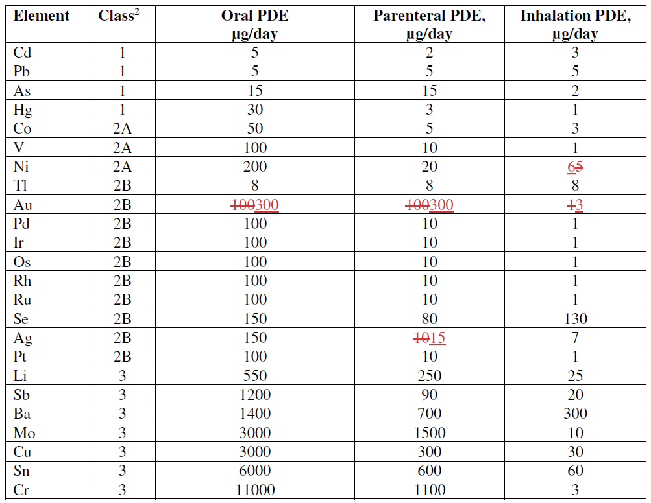  ¹PDEs reported in this table (μg/day) have been established on the basis of safety data described in the monographs in Appendix 3, and apply to new drug products. The PDEs in the monographs are not rounded. For practical purposes the PDEs in this table have been rounded to 1 or 2 significant figures. PDEs less than 10 have 1 significant figure and are rounded to the nearest unit. PDEs greater than 10 are rounded to 1 or 2 significant figures as appropriate. The principles applied to rounding in this table may be applied to PDEs derived for other routes of administration.  ² Classification as defined in Section 4.
 | Table A.2.2: Permitted Concentrations of Elemental Impurities 13 for Option 1 | The values presented in this table represent permitted concentrations in micrograms per gram for elemental impurities in drug products, drug substances and excipients. These concentration limits are intended to be used when Option 1 is selected to assess the elemental impurity content in drug products with daily doses of not more than 10 grams per day. The numbers in this table are based on Table A.2.1.  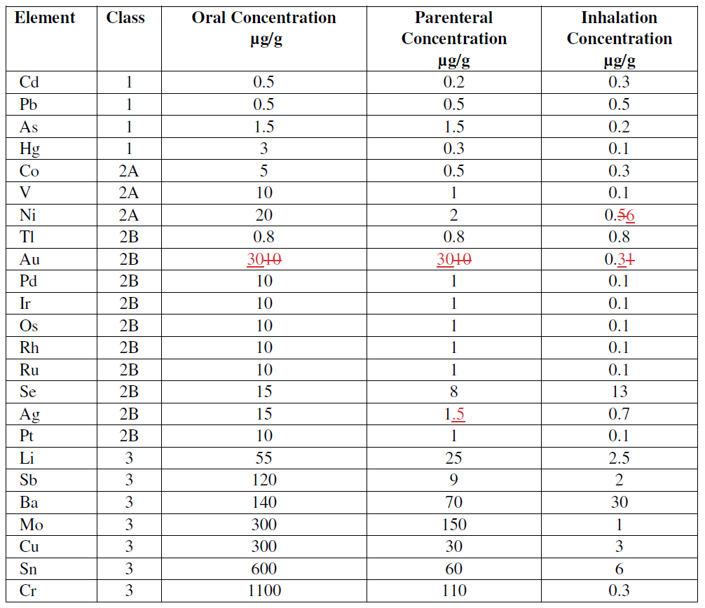
Part 2 - Q3D Appendix 3 Extract – Correction of Gold Monograph
Changes proposed to Appendix 3 are shown in track change, and are intended to be integrated into the Q3D(R2) Guideline
GOLD
 | Summary of PDE for Gold
 | Introduction | Gold (Au) exists in metallic form and in oxidation states of +1 to +5, the monovalent and trivalent forms being the most common. Elemental gold is poorly absorbed and consequently is not considered biologically active. Gold is being used on a carrier or in complexes like gold chloride and L-Au⁺ (where L is a phosphane, phosphite, or an arsine; Telles, 1998), as catalysts in organic synthesis. The only source for gold in drug products comes from the use as catalyst. Au(1+) salts are used therapeutically.
 | Safety Limiting Toxicity | Most knowledge of gold toxicity is based on therapeutic uses of gold. Currently available therapies are gold salts of monovalent Au(1+) with a sulfur ligand (Au-S), but metallic gold has also been studied. No toxicity was seen in 10 patients administered colloidal metallic gold (monoatomic gold) at 30 mg/day for one week followed by 60 mg/day the second week or the reverse schedule. The patients were continued on the trial for an additional 2 years at 30 mg/day. There was no evidence of hematologic, renal or hepatic cytotoxicity but some improvement in clinical symptoms of rheumatoid arthritis and in cytokine parameters were noted (Abraham and Himmel, 1997).  Long term animal and human data are available with gold compounds. Toxicities include renal lesions in rats administered gold compounds by injection (Payne and Saunders, 1978) and humans (Lee et al, 1965) and gastrointestinal toxicity in dogs (Payne and Arena, 1978). However, these studies have been performed with monovalent gold (Au(1+)) or forms of gold not present as pharmaceutical impurities and thus are not considered sufficiently relevant to derive a PDE for gold in pharmaceutical products.  There are no relevant toxicology studies in humans or animals by the oral route of a form of gold likely to be in a pharmaceutical product to set an oral PDE of gold. Au(3+) is thought to be the more toxic form and is used in catalysis, e.g., as gold trichloride. There is only limited data on Au(3+) complexes. In one study, the Au(3+) compound [Au(en)Cl₂]Cl (dichloro(ethylenediamine-aurate³⁺ ion) caused minimal histological changes in the kidney and liver of rats, and no renal tubular necrosis, at a dose of 32.2 mg/kg in mice rats administered the compound intra peritoneal for 14 days (Ahmed et al, 2012).
 | PDE – Oral Exposure | The toxicologically significant endpoint for gold exposures is renal toxicity. The study in mice rats administered Au(3+) by the intra peritoneal route was considered acceptable in setting the oral PDE because the renal endpoint of toxicity is a sensitive endpoint of gold toxicity. Taking into account the modifying factors (F1-F5 as discussed in Appendix 1), the oral PDE is calculated as:  PDE = 32.2 mg/kg x 50 kg / 12 5 x 10 x 10 x 1 x 10 = 134 322 μg/day  A factor of 10 for F5 was chosen because the LOAEL is used to establish the PDE and the toxicological assessment was not complete.
 | PDE – Parenteral Exposure | In humans, 50 mg intramuscular injections of gold sodium thiomalate resulted in >95% bioavailability (Blocka et al, 1986). In rabbits, approximately 70% of the gold sodium thiomalate was absorbed after an intramuscular injection of 2/mg/kg (Melethil and Schoepp, 1987). Based on high bioavailability, and that a study by the intra peritoneal route was used to set the oral PDE, the parenteral PDE is equal to the oral PDE.  PDE = 134 322 μg/day
 | PDE – Inhalation Exposure | In the absence of relevant inhalation and parenteral data, including the potential local tissue toxicity of the effects of gold in lungs, the inhalation parenteral PDE was calculated by dividing the oral PDE by a modifying factor of 100 (as described in Section 3.1).  PDE = 134 322 µg/d / 100 = 3.22 31.34 µg/day
 | REFERENCES | Abraham GE, Himmel PB. Management of rheumatoid arthritis: rationale for the use of colloidal metallic gold. J Nutr Environ Med 1997;7:295-305.  Ahmed A, Al Tamimi DM, Isab AA, Alkhawajah AMM, Shawarby MA. Histological changes in kidney and liver of rats due to gold (III) compound [Au(en)Cl2]Cl. PLoS ONE 2012;7(12):1-11.  Blocka KL, Paulus HE, Furst DE. Clinical pharmacokinetics of oral and injectable gold compounds. ClinPharmacokinet 1986;11:133-43.  Lee JC, Dushkin M, Eyring EJ, Engleman EP, Hopper J Jr. Renal Lesions Associated with Gold Therapy: Light and Electron Microscopic Studies. Arthr Rheum 1965;8(5):1-13.  Melethil S, Schoepp D. Pharmacokinetics of gold sodium thiomalate in rabbits. Pharm Res 1987;4(4):332-6.  Payne BJ, Arena E. The subacute and chronic toxicity of SK&F 36914 and SK&F D-39162 in dogs. Vet Pathol 1978;15(suppl 5): 9-12.  Payne BJ, Saunders LZ. Heavy metal nephropathy of rodents. Vet Pathol 1978;15(suppl 5):51-87.  Telles JH, Brode S, Chabanas M. Cationic gold (I) complexes: highly efficient catalysts for the addition of alcohols to alkynes. Angew Chem Int Ed 1998;37:1415-18.
Part 3 - Q3D Appendix 3 Extract – Correction of Silver Monograph
Changes proposed to Appendix 3 are shown in track change, and are intended to be integrated into the Q3D(R2) Guideline
SILVER
 | Summary of PDE for Silver
 | Introduction | Silver (Ag) is present in silver compounds primarily in the +1 oxidation state and less frequently in the +2 oxidation state. Silver occurs naturally mainly in the form of very insoluble and immobile oxides, sulfides and some salts. The most important silver compounds in drinking-water are silver nitrate and silver chloride. Most foods contain traces of silver in the 10–100 μg/kg range. Silver is nutritionally not essential and no metabolic function is known. Silver is being used as a catalyst in the oxidation of ethylene to ethylene oxide. Silver-Cadmium alloy is used in selective hydrogenation of unsaturated carbonyl compounds. Silver oxide is used as a mild oxidizing agent in organic synthesis.
 | Safety Limiting Toxicity | Silver is not mutagenic. Animal toxicity studies and human occupational studies have not provided sufficient evidence of carcinogenicity. Based on these data silver is not expected to be carcinogenic in humans (ATSDR, 1990).  Argyria appears to be the most sensitive clinical effect in response to human Ag intake. Silver acetate lozenges are used in smoking cessation (Hymowitz and Eckholdt, 1996). Argyria, a permanent bluish-gray discoloration of the skin, results from the deposition of Ag in the dermis combined with an silver-induced production of melanin. Inhalation of high levels of silver can result in lung and throat irritation and stomach pains (ATSDR, 1990).
 | PDE – Oral Exposure | Silver nitrate was added at 0.015% to the drinking water of female mice (0.9 g/mouse; 32.14 mg/kg silver nitrate; 64% silver) for 125 days to examine neurobehavioral activity of the animals based on potential neurotoxicity of silver (Rungby and Danscher, 1984). Treated animals were hypoactive relative to controls; other clinical signs were not noted. In a separate study, silver was shown to be present in the brain after mice were injected with 1 mg/kg intra peritoneal silver lactate (Rungby and Danscher, 1983). The oral PDE is consistent with the reference dose of 5 μg/kg/day (US EPA, 2003). Taking into account the modifying factors (F1-F5 as discussed in Appendix 1), the oral PDE is calculated as below.  PDE = 20 mg/kg x 50 kg / 12 x 10 x 5 x 1 x 10 = 167 μg/day  A factor 10 was chosen for F5 because the LOAEL was used to set the PDE as few toxicological endpoints were examined.
 | PDE – Parenteral Exposure | US EPA (2003) identified a LOAEL of 0.014 mg/kg Ag/day using long-term (2 to 9 years) human intravenous data based on argyria following colloidal and organic silver medication. Taking into account the modifying factors (F1-F5 as discussed in Appendix 1), the parenteral PDE is calculated as below.  PDE = 0.014 mg/kg/d x 50 kg / 1 x 10 x 1 x 1 x 5 = 14 μg/day  A factor of 5 was chosen for F5 as the finding of argyria was considered a LOEL because accumulation of silver in the skin is not considered adverse.  The safety review for silver identified one study in humans by the intravenous route published by Gaul and Staud in 1935. In this study silver arsphenamine was administered intravenously to 12 patients in 31-100 injections over 2 to 9.75 years. Based on cases presented in the study, the lowest level of silver resulting in argyria was 1 g metallic silver. Argyria was reported in other patients at higher cumulative doses of silver. Using this study, the US EPA (2003) identified this dose as a LOAEL. This study was considered inadequate to set a parenteral PDE as it involved few patients and the dosing was not adequately described. However, the study was useful in that it identified argyria as a result of cumulative dosing.  Silver is known to be absorbed across mucosal surfaces. Absorption of silver acetate occurred after ingestion of a dose of radiolabelled silver with approximately 21% of the dose being retained at 1 week (ATSDR, 1990). In a review of the oral toxicity of silver, Hadrup and Lam (2014) report that absorption of a radionuclide of silver (as silver nitrate) was between 0.4 to 18%, depending upon the species, with humans at 18%. On the basis of an oral bioavailability between 1% and 50% for silver, the parenteral PDE was calculated by dividing the oral PDE by a modifying factor of 10 (as described in Section 3.1). The recommended PDE for silver for parenteral exposure is:  PDE = 167 μg/d / 10 = 16.7 μg/day
 | PDE – Inhalation Exposure | Lung and throat irritation and stomach pains were the principal effects in humans after inhalation of high Ag levels. Using the Threshold Limit Value (TLV) of 0.01 mg/m³ for silver metal and soluble compounds (US DoL, 2013), and taking into account the modifying factors (F1-F5 as discussed in Appendix 1), the inhalation PDE is calculated as:  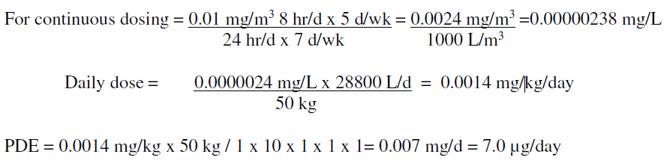
 | REFERENCES | ATSDR. Toxicological Profile for Silver. Agency for Toxic Substances and Disease Registry, Public Health Service, U.S. Department of Health and Human Services, Atlanta, GA. 1990.  Gaul LE, Staud AH. Clinical spectroscopy. Seventy cases of generalized argyrosis following organic and colloidal Ag medication. JAMA. 1935, 104:1387–1390.  Hadrup N, Lam HR. Oral toxicity of silver ions, silver nanoparticles and colloidal silver - A review. Regul Toxicol Pharmacol. 2014 68(1):1-7.  Hymowitz N, Eckholt H. Effects of a 2.5-mg silver acetate lozenge on initial and long-term smoking cessation. Prev Med 1996;25:537-46.  Rungby J, Danscher G. Hypoactivity in silver exposed mice. Acta Pharmacol Toxicol 1984;55:398-401.  Rungby J, Danscher G. Localization of exogenous silver in brain and spinal cord of silver exposed rats. Acta Neuropathol 1983;60(1-2):92-8.  US DoL (OHSA). 29 CRF 1910.1000 Table Z-1. Limits for air contaminants. U.S. Department of Labor. 2013.  US EPA. Silver (CASRN 7440-22-4). Integrated Risk Information System (IRIS). 2003.
Part 4 - Q3D Appendix 5
The new proposed Appendix 5 is intended to be integrated into the Q3D(R2) Guideline
Appendix 5: Limits for Elemental Impurities by 176 the Cutaneous and Transcutaneous Route
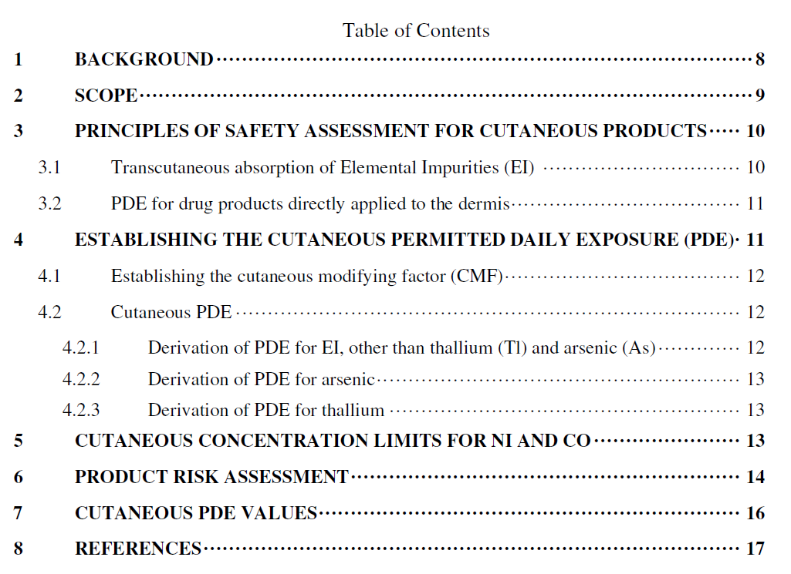
1 | BACKGROUND | In December 2014, ICH approved the ICH Q3D Guideline for Elemental Impurities developed by the Expert Working Group. The Guideline provided Permitted Daily Exposures (PDEs) for 24 elemental impurities (EI) for the oral, parenteral, and inhalation routes of administration. In section 3.2 of the guideline, principles for establishing PDEs for other routes of administration are described. During the course of the development of Q3D, interest was expressed in developing PDEs for the cutaneous and transcutaneous route, as these products remain the most significant area where PDEs for EI have not been formally established.  In establishing cutaneous and transcutaneous limits, the role of skin is paramount. The skin is an environmental barrier and a complex organ that has many functions, including limiting the penetration of exogenous materials, metabolism, prevention of water loss, temperature regulation, and as an immune organ (Monteiro-Riviere and Filon, 2017). The skin is composed of both an outer epidermis and an inner dermis, each composed of multiple cellular layers. 210 Dermal (or transcutaneous) absorption, i.e., the transport of a chemical from the outer surface of the skin into systemic circulation, is dependent upon the properties of the skin, the anatomical site, the nature of the chemical applied and the characteristics of the application.  The primary barrier to absorption is the outermost layer of the epidermis (i.e., the stratum corneum) which typically consists of 15-20 layers of non-viable cells. The stratum corneum (horny layer) serves as a highly effective barrier, especially to hydrophobic compounds and charged molecules, such as metal ions. For this reason, transcutaneous delivery into the systemic circulation of materials including any active pharmaceutical ingredient (API) typically requires physical and chemical agents (e.g., penetration enhancers) to assist in the transcutaneous absorption of the API.  In respect to these “penetration enhancers,” it is noteworthy that agents that enhance penetration of an API are usually not applicable for EI due to fundamental differences in physico-chemical properties. Limited research has been conducted to evaluate the systemic absorption of EIs applied to the skin. The skin may respond to exposure in various ways. For example, approximately half of mercury vapor taken up by the skin (1 - 4% of the dose) was shed by desquamation of epidermal cells for several weeks after exposure, while the remainder in the skin was slowly released into general circulation (Hursh et al., 1989). Hostýnek et al. (1993) describes that silver (Ag) is preferentially accumulated in the skin and is not liberated. Available data indicates that gold (Au) is not readily absorbed through skin due to inertness and lack of ionization by bodily fluids (Lansdown, 2012). Gold, in salt form, has been shown to bind readily to sulfhydryl groups of epidermal keratin and remain in the skin (Lansdown, 2012). Metal binding proteins are present in some fetal and adult skin (e.g., basal keratinocytes of epidermis and outer hair root sheath) but not in other cell types (e.g., exocrine portion of the eccrine glands), indicating the skin has the potential for binding and metabolism of metals (van den Oord and De Ley, 1994)  Together these properties of the skin layers represent a significant barrier to systemic exposure as illustrated by quantitative absorption data reviewed by Hostýnek et al. (1993). This systemic exposure is reported to be < 1% absorption for most of the evaluated EI in scope of this guideline. Transcutaneous absorption of EI is discussed in more detail in section 3.  Elements evaluated in this guideline were assessed by reviewing publicly available data contained in scientific journals, government research reports and studies, and regulatory authority research and assessment reports. In general, studies in the scientific literature simply report disappearance of EI from the cutaneous layer rather than transcutaneous absorption. Quantitative data are generally lacking for most EI and the associated counterion (Hostynek, 2003). Furthermore, there are no suitable standards for occupational exposure for the dermal route for risk assessment. Consequently, a generic approach was adopted to establish limits as opposed to an element-by-element basis.
2 | SCOPE | This Appendix to Q3D applies to cutaneous and transcutaneous drug products (referred to as “cutaneous products” throughout this Appendix) whether intended for local or systemic effect.  This Appendix does not apply to drug products intended for mucosal administration (oral, nasal, vaginal), topical ophthalmic, rectal, or subcutaneous and subdermal routes of administration.
3 | PRINCIPLES OF SAFETY ASSESSMENT FOR CUTANEOUS PRODUCTS | The literature review focuses on the forms likely to be present in pharmaceutical products (see main guideline) and therefore the assessment relied on evaluating the available data for inorganic forms of the EI and ranking the relevance of the data in the following order: human in vivo data; animal in vivo data; in vitro data.  Local and systemic toxicities were considered. In general, there is no indication for local toxicity on the skin, with the exception of sensitization. Review of systemic toxicity by the dermal route, shows significant systemic toxicity for thallium. Since there is limited information available on transcutaneous absorption of the elements addressed in this Addendum and it is not possible to address this percent absorption on an element-by-element basis and to allow conversion of an existing PDE to the dermal route in order to support an element-by-element approach. Therefore a generic approach has been developed based on a systematic adjustment of the parenteral PDE, which assumed 100% bioavailability, to derive a cutaneous PDE by using a Cutaneous Modifying Factor (CMF) (see section 4). The cutaneous PDE has been derived for daily, chronic application to the skin.
3.1 | Transcutaneous Absorption of Elemental Impurities (EI) | The extent of absorption into the systemic circulation (systemic absorption) is considered an important component to the safety assessment of the elements. Review of studies of skin penetration, absorption, systemic bioavailability and toxicity of the elements shows a lack of data for many elements. For those elements that have been studied for transcutaneous absorption and/or toxicity, the available data are rarely suitable for proper quantitative analysis and the diverse experimental designs preclude inter-study or inter-element comparability (Hostynek, 2003). The available data indicate that EIs are generally poorly absorbed through intact skin even in the presence of enhancers. For example, absorption of Pb from lead oxide under occlusion in rats was less than 0.005%, as measured by urinary Pb for 12 days following exposure. Penetration of lead oxide was not detectable in an in vitro system with human skin (ATSDR, 2019).  There are numerous factors that may influence transcutaneous absorption and systemic bioavailability after cutaneous administration of a substance. These factors may be categorized as:  - compound-related factors (e.g., physical state, ionization, solubility, binding properties, reactivity, and the counterion of the EI), and/or  - application-related factors (e.g., concentration and total dose applied, 290 duration of application/exposure, cleaning between applications, surface area, co-applied materials/excipients and occlusion status),  - subject-related factors (e.g., comparative species differences, location on the body, hydration of the skin/age, temperature).  Transcutaneous penetration through the skin is element and chemical species-specific and each element would need to be experimentally assessed under different conditions to develop an effective model. Due to this complexity, it is not feasible to address every possible scenario for ach EI in each drug product.  Given the limited amount of data on transcutaneous absorption and toxicity by the cutaneous route of administration that has been generated in well-designed studies, the available data were used to develop a generic, conservative approach. The cutaneous PDE is derived from the previously established element-specific parenteral PDEs for which adequate toxicity data are available. To address the presumed low but unquantified transcutaneous absorption, and in consideration of all the potential factors that can influence this absorption, a 10-fold factor will be applied to the parenteral PDE for most EIs. The derivation and application of the factor of 10 is described in more detail in section 4 below.
3.2 | PDE for Drug Products Directly Applied to the Dermis | A compromised basal cell layer could facilitate direct entry of EIs into the dermis and its associated blood vessels (potentially increasing systemic absorption). Therefore, the generic PDE for the cutaneous route described in this Addendum should not be applied to drug products intended to treat skin with substantial disruption of the basal cell layer of the epidermis. For indications in which drug is intentionally brought into contact with the dermis (e.g. skin ulcers, second- and third-degree burns, pemphigus, epidermolysis bullosa) it is recommended to develop a case specific justification based on principles outlined in ICH Q3D section 3.3. The parenteral PDE is generally an appropriate starting point for these drug products.  Small cuts, needle pricks, skin abrasions and other quick healing daily skin injuries are not associated with substantial basal cell layer disruption of the epidermis as defined above. The total amount of drug product which can potentially come into contact with the dermis is therefore considered negligible. Therefore, cutaneous PDEs will apply to products intended to treat these skin abrasions or other quick healing acute injuries.
4 | ESTABLISHING THE CUTANEOUS PERMITTED DAILY EXPOSURE (PDE) | The cutaneous PDE for all relevant EIs is calculated by applying a cutaneous modifying factor (CMF) to the parenteral PDE for each EI.
4.1 | Establishing the Cutaneous Modifying Factor (CMF) | The limited available data suggest that transcutaneous absorption of most EI, when studied in intact skin, is less than 1% as described previously (Section 1 and 3). As described in section 3.1, there are multiple factors that can influence this absorption. In lieu of accounting for such factors individually, and in consideration of the relative lack of reliable quantitative transcutaneous absorption data, an approach has been adopted for the derivation of cutaneous PDEs, which is considered protective against potential systemic toxicities. To account for these uncertainties, a CMF is generated using the approach outlined below.  - For EIs other than arsenic (As) and thallium (Tl), a maximum Cutaneous Bioavailability (CBA) of 1% is used.  - To account for the various factors that can enhance CBA, a factor of 10 is applied to increase the CBA (adjusted CBA).  - To calculate the CMF, the parenteral BA (100%) is divided by the adjusted CBA.
4.2 | Cutaneous PDE | The Cutaneous PDE is calculated as  Cutaneous PDE = Parenteral PDE x CMF  Parenteral PDE calculations already include safety factors F1-F5 or are derived from Oral PDE, which also include safety factors (see Appendix 1of ICH Q3D) to account for variability and extrapolation. Therefore, no further adjustments are necessary for the cutaneous PDE.  The derived cutaneous PDEs are listed in Table 1.
4.2.1 | Derivation of PDE for EI, other than Thallium (Tl) and Arsenic (As) | For EI with low CBA (< 1%), a CMF of 10 is applied.  For EI with < 1% CBA, the adjusted CBA is 1% x 10 = 10%  Divide the parenteral BA by the adjusted CBA to derive the CMF  100%/10% = 10  The cutaneous PDE is derived as:  Cutaneous PDE = Parenteral PDE x CMF  Cutaneous PDE = Parenteral PDE x 10  See Table 1 for cutaneous PDEs for individual EI.
4.2.2 | Derivation of PDE for Arsenic | For inorganic arsenic, the available data indicate that the transcutaneous absorption is greater than that observed for most other EI (approximately 5%) (ATSDR, 2016). Based on this, the CMF for arsenic is 2, as shown in the calculation below  Derive the adjusted CBA: 5% x 10 = 50%  Divide parenteral BA by the adjusted CBA to derive the CMF  100%/50% = 2  The cutaneous PDE is derived as:  Cutaneous PDE = Parenteral PDE x CMF  Cutaneous PDE = 15 μg/day x 2 = 30 μg/day
4.2.3 | Derivation of PDE for Thallium | Thallium is highly absorbed through the skin. Since quantitative data are not available, it is assumed to be effectively equivalent to parenteral levels. The adjusted PDE equals the parenteral PDE, a CMF of 1 is used.  The cutaneous PDE is derived as:  Parenteral PDE = 8 μg/day  Cutaneous PDE = 8 μg/day x 1 = 8 μg/day
5 | CUTANEOUS CONCENTRATION LIMITS FOR NI AND CO | The concentrations of EI generally present in cutaneous products as impurities are not considered sufficient to induce sensitization. However, a concentration limit in addition to the PDE is warranted for Nickel (Ni) and Cobalt (Co) to reduce the likelihood of eliciting skin reactions in already sensitized individuals. This concentration limit is referred to as the cutaneous and transcutaneous concentration limit (CTCL). For other EI such as Chromium (Cr), the threshold to elicit a sensitizing response is either approximately equal to the cutaneous PDE (Cr) or much greater than the cutaneous PDE and therefore additional controls are not necessary (Nethercott et al., 1994).  The dermal concentration limit of 0.5 μg/cm²/week for Ni was originally established by Menné et al., (1987) as a detection limit in the dimethylglyoxime (DMG) test. The use of Ni in consumer products (e.g., jewelry) intended for direct and prolonged skin contact was regulated by this limit under the EU countries Ni regulations and under the EU Nickel Directive (currently, REACH, Entry 27, Annex XVII). After implementation of the directive, the prevalence of Ni allergy decreased significantly (Thyssen et al., 2011; Ahlström et al., 2019). This limit is applied to set a cutaneous concentration of Ni in drug products. Based on application of 0.5 g dose of drug product to a skin surface area of 250 cm² (Long and Finlay, 1991), a CTCL of 35 μg/g/day drug product is derived, as below. A recently derived limit to minimize elicitation of allergies to Co shows a similar limit of 31-259 ppm (Fischer et al., 2015).  0.5 μg/cm²/week = 0.07 μg/cm²/day  0.07 μg/cm²/day x 250 cm² = 17.5 μg/day  17.5μg/day/0.5 g = 35 μg/g/day
6 | PRODUCT RISK ASSESSMENT | Product assessments for cutaneous drug products should be prepared following the guidance provided in ICH Q3D Section 5. The considerations of potential sources of EI, calculation options and considerations for additional controls are the same for products for the cutaneous route of administration as for products for the oral, parenteral and inhalation routes of administration.  For Ni and Co, in addition to considering the EI levels in the drug product relative to the PDE, the concentration of this EI (μg/g) in the drug product should be assessed relative to the CTCL identified in Table 1. The product risk assessment should therefore confirm that the total Ni and Co level (μg/day) is at or below the PDE and that their respective concentrations in the drug product does not exceed the CTCL shown in Table 1.  As described in ICH Q3D Section 5.2, the drug product risk assessment is summarized by reviewing relevant product or component specific data combined with information and knowledge gained across products or processes to identify the significant probable EI that may be observed in the drug product.  The summary should consider the significance of the observed or predicted level of the EI relative to the corresponding PDE and in the case of Ni and Co, the Ni- and Co-CTCL. As a measure of the significance of the observed EI level, a control threshold is defined as a level that is 30% of the established PDE (and CTCL for Ni and Co) in the drug product. The control threshold may be used to determine if additional controls may be required. If the total EI level - observed or predicted EI level (μg/day) or CTCL (μg/g)- from all sources in the drug product is consistently less than 30% of the established PDE, then additional controls are not required, provided the applicant has appropriately assessed the data and demonstrated adequate controls on elemental impurities.  Since the maximum total daily dose for cutaneous products is not always so clearly stated, a prerequisite for the product risk assessment is a justified estimation of a worst-case exposure that can form the basis for the assessment. (SCCP, 2006; Long, 1991, Api et al., 2008)  Dermal products differ from oral, parenteral or inhalation products in that they may be removed or rinsed from the area of application. In evaluating the potential EI to which the patient may be exposed, it may be important to evaluate the retention time of the drug product during typical conditions of use. For example, certain products such as shampoos have a 446 short application duration time. Thus, the risk assessment may propose an adjustment by use of a retention factor (see Module 1 of the ICH Q3D training package for more information on retention time; https://www.ich.org/products/guidelines/quality/article/quality-guidelines.html). If the PDE is adjusted in this manner, the new level proposed should be referred to as an Acceptable Level and is subject to consideration by the relevant authorities on a case-by-case basis.
7 | CUTANEOUS PDE VALUES | The calculated PDE for the cutaneous and transcutaneous route are listed in Table 1. To be compliant with Q3D, for sensitizing EI (Ni, Co), a second limit- the CTCL (μg/g/day)- will also need to be met.  There are insufficient data to set PDEs by any route of administration for iridium, osmium, rhodium, and ruthenium. For these elements, the palladium PDE for the relevant route will apply.  Table 2 provides example concentrations for a drug product with a daily dose of 10 g.
 | Table 1: Cutaneous products – PDE, CTCL and elements to be included in risk assessment | 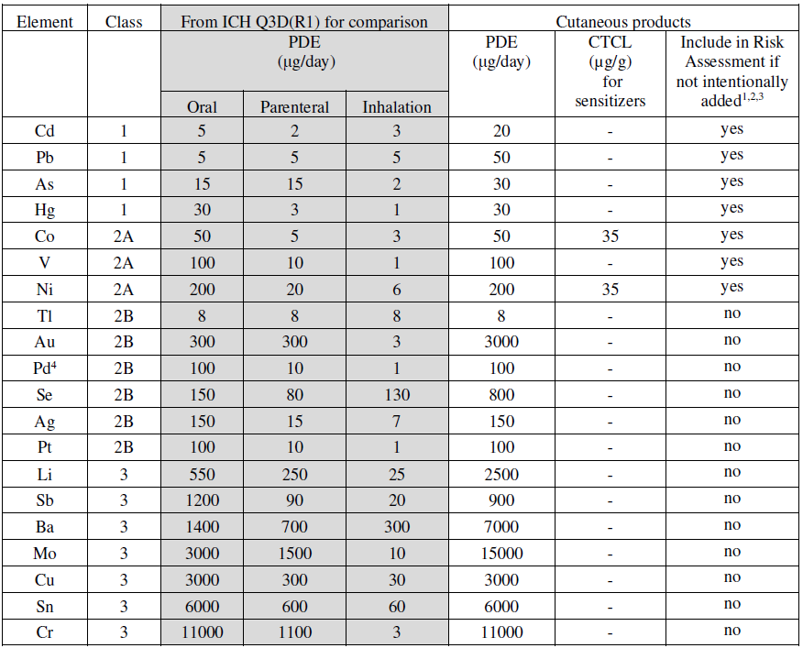  ¹ Intentionally added elements should always be included in the Risk Assessment.  ² Class 2B elements were excluded from the assessment of oral, parenteral and inhalation products due to the low likelihood that they would be present if not intentionally added (see section 4 of ICH Q3D).  ³ Class 3 elements with a cutaneous PDE above 500 μg/day do not have to be included in the risk assessment unless intentionally added (see section 4 of ICH Q3D)  ⁴ Pd PDE will apply to iridium, osmium, rhodium, and ruthenium.
 | Table 2: Cutaneous PDE and Concentration Limits 468 for a 10 g Dose | 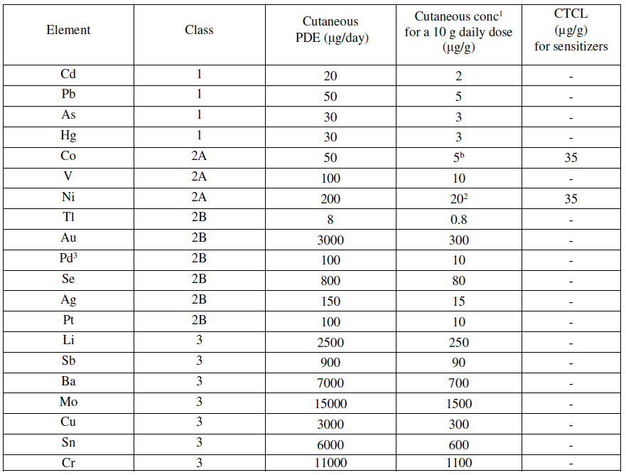  ¹ PDE expressed in concentration terms, calculated using a 10 g daily dose;  ² For elements with a cutaneous PDE and a CTCL, both limits need to be met. In case, the results are conflicting the lowest limit needs to be applied. As example: for Co: based on a 10 g dose, the calculated cutaneous concentration is 5 μg/g is; a 1 g dose would permit a daily concentration of 50 μg/g, exceeding the CTCL of 35 μg/g. In this situation, the CTCL limit should be used.  ³ Pd PDE will apply to iridium, osmium, rhodium, and ruthenium.
8 | REFERENCES | Ahlström MG, Thyssen JP, Wennervaldt M, Menné T, Johansen JD. Nickel allergy and allergic contact dermatitis: A clinical review of immunology, epidemiology, exposure and treatment. Contact Dermatitis 2019; 1-15.  Api AA, Basketter DA, Cadby PA, Cano MF, Ellis G, Gerberick ZF, Griem P, McNamee PM, Ryan CA, Safford R. Dermal sensitization quantitative risk assessment (QRA) for fragrance ingredients. Reg Toxicol Pharmacol 52 (1) 2008, 3-23.  ATSDR. Toxicological profile for lead. Agency for Toxic Substances and Disease Registry, Public Health Service, U.S. Department of Health and Human Services, Atlanta GA. 2019.  ATSDR. Addendum to the toxicological profile for arsenic Agency for Toxic Substances and Disease Registry, Public Health Service, U.S. Department of Health and Human Services, Atlanta GA. 2016.  Fischer LA, Johansen JD, Voelund A, Lidén C, et al. Elicitation threshold of cobalt chloride: analysis of patch test dose-response studies. Contact Dermatitis 2015; 74: 105-109.  Hostýnek JJ, Hinz RS, Lorence CR, Price M, Guy RH. Metals and the skin. Critical Reviews in Toxicology 1993; 23(2): 171-235.  Hostynek JJ. Factors determining percutaneous metal absorption. Food Chem Toxicol 2003; 41 (3): 327–345.  Hursh JB, Clarkson TW, Miles EF, Goldsmith LA. Percutaneous absorption of mercury vapor by man. Arch Environ Health 1989; 44(2): 120-127.  Lansdown ABG. Silver and Gold. In Patty’s Toxicology 6th Edition. Ed Bingham E., Cohrssen B; John Wiley & Sons 2012; pp 75-112  Long CC, and Finlay AY. The Finger-Tip Unit-a New Practical Measure. Clinical and experimental dermatology. 1991; 16.6: 444–447.  Menné T, Brandup F, Thestrup-Pedersen K et al. Patch test reactivity to nickel alloys. Contact Dermatitis 1987; 16: 255-259.  Monteiro-Riviere NA, Filon, FL. Skin. In B Badeel, A Pietroiusti and Anna A. Shvedova Adverse Effects of Engineered Nanomaterials. Exposure, Toxicology and Impact on human Health 2nd Edition 2017: 357-380 Elsevier  Nethercott J, Paustenbach D, Adams R, Fowler J, et al. A study of chromium induced allergic contact with 54 volunteers: implications for environmental risk assessment. Occup Environ Med 1994; 51: 371-380.  SCCP’s (European Commission Scientific Committee on Consumer Products) Notes of Guidance for the Testing of Cosmetic Ingredients and Their Safety Evaluation, sixth revision, 2006. http://ec.europa.eu/health/ph_risk/committees/04_sccp/docs/sccp_o_03j.pdf .  Thyssen JP, Uter W, McFadden J, Menné T, Spiewalk R, Vigan M, Gimenez-525 Arnau A, Lidén C. The EU Nickel Directive revisited—future steps towards better protection against nickel allergy. Contact Dermatitis. 2011; 64(3): 121-125.  Van den Oord JJ and De Ley M. Distribution of metallothionein in normal and pathological human skin. Arch Dermatol Res 1994; 286: 62-8.

